**Integrated Mobile Application for Emergency Medical Assistance: Real-Time Hospital Proximity and Treatment Facility Tracking Using Google Maps API**

## A PROJECT REPORT

***Submitted by,***

**Ramya Hanamanth Sataraddi - 20211CSE0370**

**Tejeswini L -20211CSE0356**

**Deekshitha M – 20211CSE0526**

### *Under the guidance of,*

**Dr. SenthilKumar S**

**Professor**

**School of Computer Science and Engineering**

**Presidency University**

***in partial fulfillment for the award of the degree of***

**BACHELOR OF TECHNOLOGY**

**IN**

**COMPUTER SCIENCE AND ENGINEERING**

**At**



**PRESIDENCY UNIVERSITY**

**BENGALURU JANUARY 2025**

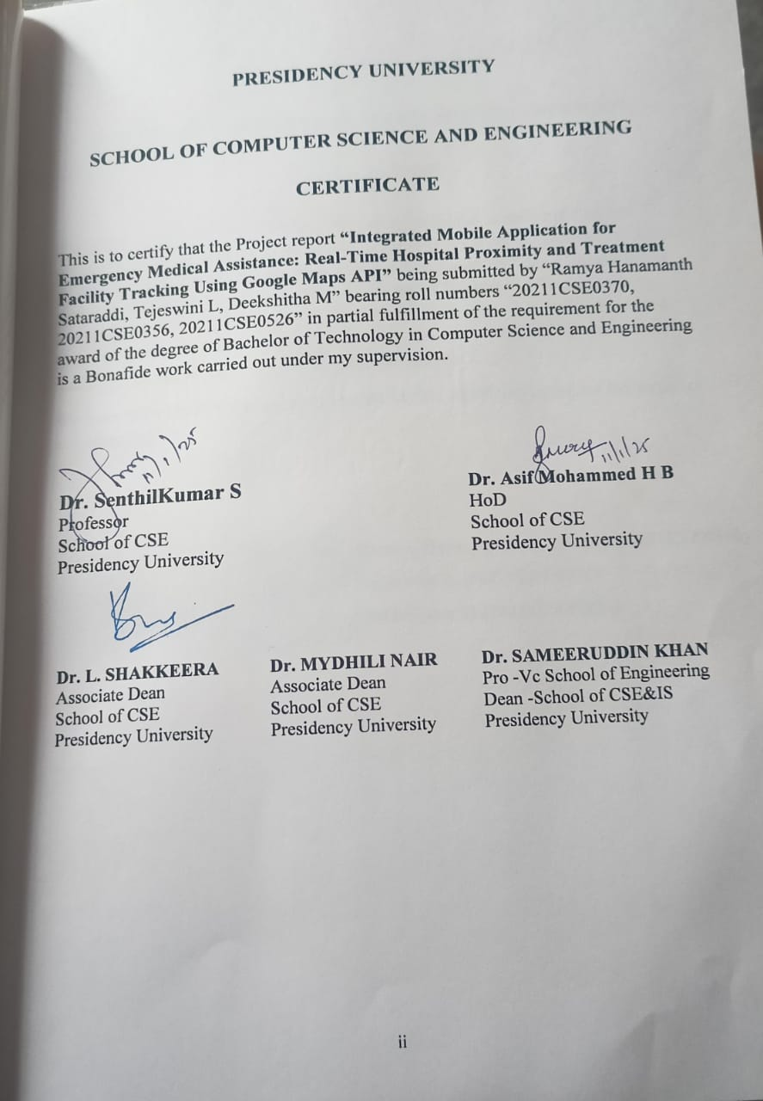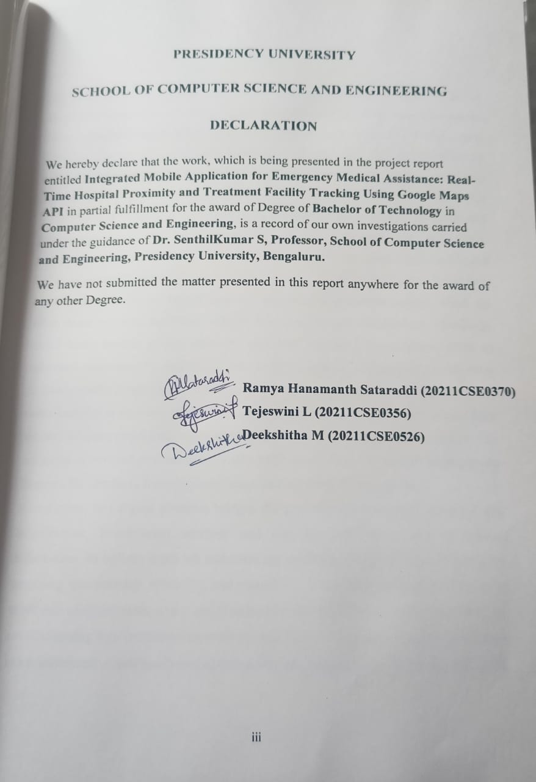**ABSTRACT**

The proposed system introduces a comprehensive digital platform designed to address the critical needs of the healthcare sector. This innovative solution integrates essential information from hospitals, blood banks, and medical professionals into a single, user-friendly interface. By leveraging modern technology, the platform significantly enhances the accessibility, reliability, and efficiency of healthcare services, catering to the needs of both providers and beneficiaries. One of the standout features of the system is its seamless integration of hospital data. Hospitals can log in to the platform and update key details, such as bed availability, specialist services, and other critical information, in real time. This ensures transparency and allows users to make quick and informed decisions, especially in emergencies where every second counts. The system reduces the reliance on manual processes and telephonic communication, which are often prone to delays and errors, thereby improving operational efficiency. Similarly, blood banks benefit greatly from this platform. For users, the platform offers an enhanced experience by simplifying the search for medical resources. It enables them to locate nearby hospitals and blood banks based on their specific needs or search for these facilities in a particular city. In addition, users can access recommendations from verified doctors, which helps them make informed decisions about their healthcare. The inclusion of verified profiles ensures that patients can trust the medical professionals listed on the platform, fostering confidence and reliability in the system.

In summary, this digital platform bridges the gap between healthcare providers and beneficiaries, streamlining services and ensuring real-time access to critical information. Its holistic approach addresses the inefficiencies of traditional systems by providing transparency, reliability, and ease of use. From hospitals and blood banks to users and administrators, every stakeholder benefits from this integrated solution. By revolutionizing how healthcare services are accessed and managed, this platform stands as a transformative tool in advancing the quality of care and improving health outcomes.

**ACKNOWLEDGEMENT**

First of all, we indebted to the **GOD ALMIGHTY** for giving me an opportunity to excel in our efforts to complete this project on time.

We express our sincere thanks to our respected dean **Dr. Md. Sameeruddin Khan**, Pro-VC, School of Engineering and Dean, School of Computer Science Engineering & Information Science, Presidency University for getting us permission to undergo the project.

We express our heartfelt gratitude to our beloved Associate Deans **Dr. Shakkeera L and Dr. Mydhili Nair,** School of Computer Science and Engineering, Presidency University, and **Dr. Asif Mohammed H B**, Head of the Department, School of Computer Science and Engineering, Presidency University, for rendering timely help in completing this project successfully.

We are greatly indebted to our guide **Dr. SenthilKumar S, Professor** and Reviewer **Dr. Chandrashekar, Professor,** School of Computer Science and Engineering, Presidency University for his inspirational guidance, and valuable suggestions and for providing us a chance to express our technical capabilities in every respect for the completion of the project work.

We would like to convey our gratitude and heartfelt thanks to the PIP2001 Capstone Project Coordinators **Dr. Sampath A K, Dr. Abdul Khadar A and Mr. Md Zia Ur Rahman,** department Project Coordinators **Mr. Amarnath J L/ Dr Jayanthi K**

and Git hub coordinator **Mr. Muthuraj.**

We thank our family and friends for the strong support and inspiration they have provided us in bringing out this project.

**Ramya Hanamanth Sataraddi**

**Tejeswini L**

**Deekshitha M**

**LIST OF FIGURES**

|  |  |  |  |
| --- | --- | --- | --- |
| **Sl. No.** | **Figure Name** | **Caption** | **Page No.** |
| 1  2  3  4  5  6  7  8  9  10  11  12  13  14  15  16  17  18  19  20  21 | Figure 4.4  Figure 4.5 .1  Figure 4.5 .2  Figure 4.5 .3  Figure 4.5 .4  Figure 4.5 .5  Figure 4.5 .6  Figure 4.5 .7  Figure 4.5 .8  Figure 6.2. 1  Figure 6.2. 2  Figure 6.2. 3  Figure 6.2. 4  Figure 6.2. 5  Figure 6.2. 6  Figure 6.2. 7  Figure 6.2. 8  Figure 6.2. 9  Figure 6.2. 10  Figure 6.2. 11  Figure 7.1 | Architecture Design  Agile Model  Android Architecture  Installation Path of the Android SDK  SDK Starter Package Download  ADT Plugin for Eclipse Installation  Utilizing the SDK tools  Adding Platforms and Components  Installing Archives  Hospital Use Case Diagram  User and Hospital Use Case Diagram  Admin Use Case Diagram  Class Diagram  Sequence Diagram  Collaboration Diagram  Activity Diagram  Component Diagram  Deployment Diagram  ER Diagram  Data Flow Diagram  Gantt Chart | 13  15  17  22  23  25  25  26  27  33  33  34  34  35  35  36  37  37  38  39  43 |

**TABLE OF CONTENTS**

|  |  |  |
| --- | --- | --- |
| **CHAPTER NO.** | **TITLE** | **PAGE NO.** |
|  |  |  |
|  | **ABSTRACT**  **ACKNOWLEDGMENT**  **LIST OF FIGURES**  **TABLE OF CONTENTS** | **iv**  **v**  **vi**  **vii** |
|  | **INTRODUCTION** |  |
|  | 1.1 Motivation……………………………………………………....... | 1 |
|  | 1.2 Problem Statement……………………………….......................... | 2 |
|  | 1.3 Objective of the Project……………………………………........... | 3 |
|  | 1.4 Scope………………………………………………………........... | 3 |
|  | 1.5 Project Introduction………………………………………………. | **4** |
|  | **LITERATURE REVIEW** |  |
|  | 2.1 Related Work…………………………………….......................... | 7 |
|  | **RESEARCH GAPS OF EXISTING METHODS** |  |
|  | 3.1 Existing System…………………………………………………... | 10 |
|  | 3.2 Disadvantages of the existing system……………………............. | 10 |
|  | 3.3 Proposed System…………………………………………………. | 10 |
|  | 3.4 Advantages of the proposed System……………………………... | 11 |
|  | **PROPOSED METHODOLOGY** |  |
|  | 4.1 Functional and Non-Functional Requirements…………………... | 12 |
|  | 4.2 Hardware Requirements……………………………….................. | 13 |
|  | 4.3 Software Requirements…………………………………………... | 13 |
|  | 4.4 Architecture………………………………………………............. | 13 |
|  | 4.5 Software Development Life Cycle…………………….................. | 14 |
|  | **OBJECTIVES** |  |
|  | 5.1 Centralization of Healthcare Data………………………............... | 30 |
|  | **SYSTEM DESIGN & IMPLEMENTATION** |  |
|  | 6.1 Introduction to Input Design……………………………............... | 31 |
|  | 6.1.1 Output Design…………………………………….……….. | 31 |
|  | 6.1.2 Principle of Output Design……………………………........ | 31 |
|  | 6.2 UML Diagram……………………………………………………. | 32 |
|  | 6.2.1 Goals of UML…………………………………………........ | 32 |
|  | 6.2.2 Use case diagram…………………………………………… | 32 |
|  | 6.2.3 Class Diagram…………………………………………........ | 34 |
|  | 6.2.4 Sequence Diagram…………………………………………. | 34 |
|  | 6.2.5 Collaboration Diagram…………………………................... | 35 |
|  | 6.2.6 Activity Diagram…………………………………………… | 36 |
|  | 6.2.7 Component Diagram………………………………….......... | 36 |
|  | 6.2.8 Deployment Diagram………………………………………. | 37 |
|  | 6.2.9 ER Diagram………………………………………………… | 38 |
|  | 6.3 Data Flow Diagram………………………………………………. | 39 |
|  | 6.4 Implementation…………………………………………………… | 40 |
|  | 6.4.1 Admin Module……………………………………………... | 40 |
|  | 6.4.2 Doctor Module……………………………………………... | 40 |
|  | 6.4.3 Blood Bank Module………………………………………... | 41 |
|  | 6.4.4 User Module………………………………………………... | 41 |
|  | 6.4.5 Specialist Doctors (SDoctors) Module……………………... | 42 |
|  | **TIMELINE FOR EXECUTION OF PROJECT** |  |
|  | 7.1 Gantt Chart………………………………………………….......... | 43 |
|  | **OUTCOMES** |  |
|  | 8.1 Outcomes……………………………………………………......... | 44 |
|  | **RESULTS AND DISCUSSIONS** |  |
|  | 9.1 Stakeholder Involvement………………………………………… | 45 |
|  | 9.2 Technical Considerations………………………………………… | 45 |
|  | 9.3 Challenges………………………………………………………... | 45 |
|  | 9.4 Potential Risks……………………………………………………. | 46 |
|  | 9.5 Ethical and Social Impacts……………………………………….. | 46 |
|  | 9.6 Future Directions…………………………………………………. | 46 |
|  | 9.7 Key Metrics for Success………………………………………….. | 47 |
|  | 9.8 Collaborative Opportunities……………………………………… | 47 |
|  | **CONCLUSION** |  |
|  | 10.1 Conclusion………………………………………………………. | 48 |
|  | 10.2 Future Enhancements……………………………………............ | 48 |
|  | **REFERENCES………………………………………………………** | 49 |
|  | **APPENDIX A (PSUEDOCODE)…………………………………...** | 51 |
|  | **APPENDIX B (SCREENSHOTS)………………………………….** | 59 |
|  | **APPENDIX C (ENCLOSURES)…………………………………...** | 62 |
|  |  |  |
|  |  |  |
|  |  |  |
|  |  |  |
|  |  |  |
|  |  |  |
|  |  |  |
|  |  |  |
|  |  |  |
|  |  |  |
|  |  |  |
|  |  |  |
|  |  |  |
|  |  |  |

**CHAPTER-1**

**INTRODUCTION**

**1.1 Motivation**

The healthcare sector is undeniably a cornerstone of human development, playing a critical role in safeguarding lives and promoting well-being. However, it continues to face persistent challenges in ensuring timely and equitable access to vital medical services. Despite rapid advancements in medical technology and infrastructure, the integration of digital solutions in healthcare remains underutilized. This gap is particularly evident in the absence of platforms that provide real-time updates and seamless coordination among hospitals, blood banks, and healthcare professionals. This lack of integration often leads to inefficiencies that directly impact patient outcomes and overall public health.

The motivation behind our initiative stems from the pressing need to address these gaps, which have real-world consequences for millions of individuals. Delays in accessing medical resources such as hospital beds, blood for transfusions, or consultations with reliable healthcare professionals result in countless lives being lost each year. For example, during emergencies such as accidents, natural disasters, or critical surgeries, patients and their families often find themselves frantically searching for available hospital facilities or specific blood types. These delays lead to frustration, emotional distress, and in severe cases, the irreversible loss of life.

Consider the following scenario: a car accident victim arrives at a hospital only to find that no ICU beds are available. The family is left with the daunting task of contacting other hospitals or searching for help without a centralized resource. Similarly, a patient with a rare blood type in need of an urgent transfusion may face significant challenges locating a blood bank with the required inventory. These inefficiencies highlight the critical need for a solution that can facilitate timely access to medical resources, reduce the burden on patients and caregivers, and ultimately save lives.

Our proposed unified digital healthcare platform aims to bridge these systemic gaps and provide an innovative solution to these challenges. The platform is designed to serve as a reliable, user-friendly tool that connects users with essential healthcare resources in real time. Unlike traditional methods that rely heavily on manual processes, such as phone calls or fragmented data systems, this digital platform consolidates information from hospitals, blood banks, and healthcare professionals into a centralized hub. By doing so, it transforms how healthcare services are accessed and managed.

At its core, the platform is driven by the vision of fostering transparency and ensuring that critical medical information is readily available to those who need it. Hospitals can update bed availability in real time, allowing patients to make informed decisions during emergencies. Blood banks can maintain accurate inventories of available blood types, reducing delays for patients in need of transfusions. Additionally, users can search for verified healthcare professionals, ensuring that they receive consultations and care from trusted sources. This level of integration promotes efficiency in resource allocation, minimizes wastage, and ensures that no individual is denied timely medical attention due to a lack of information.

Transparency and user-friendliness are key motivators behind the development of this platform. By providing real-time data updates and intuitive interfaces, the system eliminates the guesswork and inefficiencies often associated with accessing healthcare services. For instance, a user can input their location and search for nearby hospitals with available ICU beds or locate a blood bank with a specific blood type. This ability to access critical information within seconds can make a life-saving difference during emergencies. Beyond emergencies, the platform also addresses routine healthcare needs by offering reliable doctor recommendations and access to nearby healthcare facilities, streamlining the user’s journey.

Another significant motivator is the potential to reduce the strain on healthcare providers. In the current system, hospitals and blood banks often face an overwhelming number of inquiries during crises, which diverts attention away from patient care. By automating the dissemination of information through this platform, healthcare providers can focus their efforts on delivering quality care, knowing that patients have a reliable tool to access essential details. This collaboration between technology and healthcare professionals fosters a more efficient and patient-centric system.

Our vision extends beyond addressing immediate challenges. The platform lays the foundation for future innovations in healthcare delivery. For example, it could be expanded to include telemedicine services, enabling virtual consultations for patients who cannot visit healthcare facilities in person. Predictive analytics could be incorporated to anticipate resource needs based on trends and historical data, further improving efficiency and preparedness. Additionally, patient feedback systems could help drive continuous improvement, ensuring that the platform evolves to meet changing healthcare demands.

In conclusion, the motivation for developing this unified digital healthcare platform is rooted in the belief that no individual should face unnecessary obstacles when seeking medical care. By addressing gaps in transparency, accessibility, and resource allocation, this platform aspires to revolutionize healthcare delivery and set a new standard for digital healthcare solutions. It is a step toward a future where technology and healthcare work hand in hand to save lives, reduce disparities, and create a more equitable and efficient medical ecosystem.

**1.2 Problem Statement**

The current healthcare system is plagued by inefficiencies that stem from its reliance on outdated communication methods. Hospitals, blood banks, and healthcare providers often operate in silos, lacking the coordination necessary to respond effectively to patients' needs. Critical information, such as bed availability, blood stock levels, and verified doctor recommendations, is not readily accessible to users.

For instance, patients searching for available hospital beds during the COVID-19 pandemic often faced confusion and delays due to the lack of a centralized information platform. Similarly, individuals in need of rare blood types frequently encounter difficulties locating donors or blood banks that can meet their requirements. These scenarios highlight the pressing need for a system that integrates and centralizes medical data to enable swift decision-making.

The absence of such a platform hampers timely access to healthcare services, impacting not only patients but also providers. Without real-time transparency, resources remain underutilized, and patients suffer due to the resulting delays. This project seeks to address these challenges by offering an innovative solution that integrates data from diverse healthcare providers into a single, easily accessible platform.

**1.3 Objective of the Project**

The primary objective of this project is to develop an integrated digital healthcare platform that centralizes and streamlines information from hospitals, blood banks, and medical professionals. The system is designed to provide users with real-time, verified data, enabling them to make informed decisions during medical emergencies and routine healthcare needs.

Key objectives of the project include:

* **Enhancing Accessibility:** Ensuring that users can easily access accurate and up-to-date information about bed availability, blood stocks, and doctor recommendations.
* **Improving Transparency:** Providing a centralized platform that fosters trust by offering real-time updates and verified data.
* **Streamlining Healthcare Services:** Reducing inefficiencies and delays caused by manual processes and disjointed communication channels.
* **Empowering Administrators:** Equipping admins with tools to verify doctor profiles, onboard new medical entities, and maintain data accuracy.

By achieving these objectives, the platform aims to create a user-friendly, reliable, and efficient healthcare ecosystem that benefits all stakeholders.

**1.4 Scope**

The scope of this project encompasses the design, development, and implementation of a comprehensive digital healthcare platform. This platform is envisioned as a one-stop solution that integrates information from hospitals, blood banks, and doctors, offering a wide range of features tailored to meet diverse healthcare needs.

Features Included:

* **Real-Time Updates**: Hospitals can update bed availability and other essential details, while blood banks manage their inventory of blood groups in real time.
* **Location-Based Search**: Users can search for nearby hospitals and blood banks based on their location or specific cities.
* **Doctor Recommendations**: Verified doctor profiles are made accessible to users, enabling them to seek credible medical advice.
* **Admin Oversight**: A robust admin panel allows administrators to maintain the accuracy of the database, onboard new hospitals and blood banks, and verify doctor profiles.
* **User-Friendly Interface**: The platform is designed to be intuitive and easy to navigate, catering to a broad audience with varying levels of technical expertise.

By integrating these features, the platform aims to address current shortcomings in healthcare systems, offering a more transparent, efficient, and user-centric solution. The scope also extends to future enhancements, such as the incorporation of predictive analytics, telemedicine services, and preventive healthcare features, ensuring the platform’s long-term relevance and impact.

**1.5 Project Introduction**

In the current digital era, where technology plays a pivotal role in transforming industries, the healthcare sector still struggles with fundamental challenges. Despite remarkable advancements in medical science and the widespread adoption of digital tools across various domains, accessing healthcare services remains a daunting task for many individuals. This issue primarily stems from fragmented systems and outdated communication methods, which hinder the seamless delivery of essential medical services. Consider the case of a patient experiencing a medical emergency, such as a heart attack, where every second counts. The inability to access real-time information about nearby hospitals with available ICU beds can mean the difference between life and death. Similarly, patients in need of blood transfusions, especially those requiring rare blood types, often face unnecessary delays due to the absence of a centralized system that tracks blood bank inventories. These examples highlight the urgent need for a robust, integrated platform that addresses these critical gaps in healthcare access.

The proposed digital healthcare platform is a groundbreaking solution that aims to revolutionize how medical resources are accessed and managed. By consolidating information from hospitals, blood banks, and doctors, the system provides a seamless user experience tailored to meet both urgent and routine healthcare needs. Unlike traditional systems that operate in silos, this platform offers a unified solution, eliminating the inefficiencies caused by miscommunication and fragmented data sources.

**Real-Time Transparency and Updates**

One of the platform's standout features is its real-time transparency, which enables hospitals to update bed availability and other crucial details efficiently. This feature is particularly valuable during emergencies. For instance, during the COVID-19 pandemic, the lack of a centralized system to track hospital bed occupancy led to significant delays in patient care. With this platform, users can quickly locate hospitals with available resources, such as ICU or ventilator-equipped beds, drastically reducing response times and potentially saving lives. In addition to bed availability, blood banks play a critical role in emergency healthcare situations. The platform allows blood banks to update their inventory regularly, ensuring that users can access accurate information about available blood types. Imagine a scenario where a patient with a rare blood type needs an urgent transfusion. The platform can help locate the nearest blood bank with the required stock, saving valuable time and effort that would otherwise be spent making phone calls or visiting multiple locations.

**Location-Based Search Functionality**

Another key feature of the platform is its location-based search functionality, which enables users to find nearby medical facilities and services based on their current location or specific preferences. This is especially beneficial for travelers or individuals in unfamiliar cities. For example, a tourist visiting a new city who suddenly falls ill can use the platform to locate the nearest hospital, view available doctors, and even identify nearby blood banks if needed. The intuitive design ensures that users can access this information within seconds, making the platform an invaluable tool in both everyday healthcare and emergency scenarios.

This location-based feature also supports advanced filtering options, allowing users to search for facilities that meet specific criteria, such as 24-hour availability, specialized care units, or specific medical services. By providing such tailored search capabilities, the platform ensures that users receive the most relevant and actionable information.

**Robust Administrative Oversight**

At the heart of the system lies a robust admin panel, which plays a pivotal role in maintaining the platform's credibility and reliability. Administrators are tasked with onboarding new hospitals and blood banks, verifying doctor profiles, and ensuring that the database remains accurate and up-to-date. This administrative oversight is critical to the platform's success, as it guarantees that users can trust the information provided. For example, before a hospital or blood bank is added to the platform, admins verify their credentials and validate the accuracy of the data submitted. Similarly, doctor profiles undergo rigorous checks to confirm their qualifications and professional history, ensuring that users receive recommendations they can rely on. This focus on data integrity not only builds trust but also sets the platform apart from other healthcare applications that may lack such stringent verification processes. Admins are also responsible for monitoring system performance and addressing any technical or operational issues. For instance, if a hospital fails to update its bed availability or provides incorrect data, admins can intervene promptly to rectify the situation. This proactive approach ensures that the platform remains a dependable resource for all users.

**Transforming Healthcare with Technology**

By leveraging modern technology, the platform goes beyond addressing current challenges; it lays the groundwork for future innovations in healthcare delivery. The integration of real-time updates, location-based searches, and robust administrative oversight represents a significant step forward in improving accessibility, efficiency, and transparency in healthcare.

The platform's potential for scalability further underscores its transformative impact. Future enhancements could include features such as telemedicine services, predictive analytics to anticipate healthcare resource demands, and patient feedback systems to drive continuous improvement. By embracing these possibilities, the platform is well-positioned to remain at the forefront of digital healthcare innovation.

In conclusion, the proposed digital healthcare platform is not just a solution to existing challenges but a catalyst for a more efficient and patient-centric healthcare ecosystem. Its focus on transparency, user-friendliness, and reliability ensures that it meets the diverse needs of patients, healthcare providers, and administrators alike. As the healthcare landscape continues to evolve, this platform promises to redefine how medical resources are accessed and managed, setting a new standard for digital healthcare solutions.

**CHAPTER-2**

**LITERATURE SURVEY**

**2.1 Related Work**

**[1] Blood donation and life saver-blood donation app; M.R. Anish Hamlin; J. Albert Mayan. 24 July 2017.** Blood is an essential component for sustaining life, yet the number of blood donors remains significantly low compared to other nations. This project introduces an innovative and effective approach to address this issue. The proposed system allows donors to register by entering personal details such as name, contact information, age, weight, date of birth, blood group, and address. When a user specifies the required blood group, the system identifies and alerts suitable donors in the vicinity. If the primary donor is unavailable, the app automatically locates the next donor in the queue. Additionally, the app removes donor details temporarily (for three months) after a successful donation to ensure compliance with health standards. This system aims to provide a streamlined process for finding blood donors in emergencies.

**[2] Blood bank information system using Android application Publisher: IEEE Cite This PDF: Neetu Mittal; Karan Snotra; 14 May 2018.** Ensuring the availability of blood during emergencies is crucial. While there are several electronic blood donation platforms, these systems often fail to establish immediate contact between donors and recipients, presenting a significant limitation. Existing systems are labor-intensive, time-consuming, and costly. This study compares current blood bank frameworks with an improved version designed to enhance efficiency. The proposed system transitions from traditional desktop frameworks to mobile platforms, offering portability and ease of access. Features include storing data for future use and tracking details of blood donations and receipts, which can significantly improve the current blood bank systems' efficacy and accessibility.

**[3] mHealth: Blood donation application using android smartphone; Muhammad Fahim; Halil Ibrahim Cebe; Jawad Rasheed; Farzad Kiani; 18 August 2016.** Mobile health (mHealth) solutions are emerging as a promising avenue for providing healthcare services through mobile devices and communication technologies. Blood donation, being a complex and time-sensitive process, greatly benefits from such solutions. This study presents an Android-based blood donation application as an mHealth tool to connect donors and requesters anytime, anywhere. The app enables users to locate available donors in their vicinity and broadcasts requests across a network of registered volunteers. Donors willing to help are immediately notified, facilitating rapid response during emergencies. Evaluations showed that the application significantly improves timely access to blood donation services, fostering better outcomes in critical situations.

**[4] Implement Android Application for Book Donation; Arushi Singh; Shilpi Sharma; 06 August 2020.** Books are a valuable resource and a cornerstone of knowledge-sharing, yet many individuals have unused books lying idle at home while others struggle to access the learning materials they need. This paper introduces a mobile application named *Bridge* to address this gap by providing an innovative platform for connecting book donors with recipients. The app is built on the widely used Android platform, chosen for its extensive support and ease of use for both developers and end-users. By enabling users to register and create detailed profiles, the app allows donors to list the books they wish to contribute. Potential recipients can search for available books based on criteria like title, author, or subject area, ensuring a targeted and efficient matching process. Once a match is found, the app facilitates interaction between the donor and recipient to arrange for book collection or delivery. Moreover, the app emphasizes sustainability and the broader social impact of reusing resources.

**[5] Design Mobile Application for Blood Donation System; Muna M. Hummady; 14 February 2023**. As digital technology becomes increasingly integrated into daily life, mobile applications have proven essential for addressing critical challenges, particularly during the COVID-19 pandemic. Finding a reliable blood bag or donor can be a matter of life and death, especially for patients with conditions like thalassemia, cancer, or those requiring emergency surgery. This project proposes a mobile application to address these challenges, integrating a centralized database that compiles and organizes information from blood banks and donation drives. The app's front end, developed using JavaScript with React Native, provides an interactive user experience, while Firebase serves as the backend database. This system ensures streamlined blood donation processes and improves the management of rare blood types and donor information, enhancing accessibility and trustworthiness.

**[6] Priya, P., Saranya, V., Shabana, S., & Subramani, K. (2014)**: This study explores the optimization of blood donor information and management systems using Technopedia, a technological framework designed to enhance efficiency. The system aims to streamline the collection, storage, and retrieval of donor information, ensuring that blood banks can respond promptly to emergencies and routine demands. It emphasizes the need for a robust database capable of organizing donor details, blood group availability, and medical eligibility in a systematic manner. This approach not only minimizes wastage of blood due to storage constraints but also ensures that critical demands are met without delays. The paper underlines the importance of technology in building resilient healthcare systems that are responsive and efficient.

**[7] Agrawal, S., Deshmukh, S., Rawade, R., Desai, M., & Deshmukh, P. (2016)**: This research focuses on a smart application developed for food donation using cloud computing technologies. The application bridges the gap between surplus food providers, such as restaurants or households, and individuals or organizations in need. By using cloud platforms, the application enables real-time data exchange, ensuring food is distributed efficiently before spoilage. The study discusses how this system can significantly reduce food waste while addressing hunger, making it an innovative solution for urban and rural areas alike. The application 2019s design emphasizes simplicity and user-friendliness, allowing donors to log food details and recipients to locate available resources quickly. Additionally, it integrates features for tracking donations and generating reports to encourage transparency and accountability.

**[8] Jenipha, T. H., & Backiyalakshmi, R. (2014)**: This paper introduces an Android application designed to connect blood donors with recipients through a cloud computing platform. The app provides an essential lifesaving service by enabling users to locate and contact nearby donors during emergencies. The study focuses on the system 2019s architecture, which ensures scalability, data security, and accessibility, making it suitable for use across various regions and demographics. By leveraging cloud technology, the application ensures that donor and recipient data is available in real time, significantly reducing response times. The research also highlights the user-centric features of the application, such as location-based services and automated notifications. The paper illustrates the practical benefits of combining mobile and cloud technologies to address critical challenges in healthcare, emphasizing its potential to save lives and improve service delivery.

**[9] Sirait, M. (2017):** This study focuses on an Android application designed to transform urban solid waste management by incentivizing users to recycle. The app encourages individuals to dispose of waste responsibly by offering rewards for recycling, thus turning trash into cash. By creating an ecosystem where waste management becomes economically viable for users, the application addresses two critical issues: environmental sustainability and urban waste management. The study explores the technical framework of the app, detailing its ability to track user activity, calculate rewards, and connect with recycling centers. The paper also discusses the broader implications of such systems, including the reduction of landfill dependency and promotion of circular economy principles. This innovative solution demonstrates the power of mobile technology in addressing complex urban challenges.

**[10]** **Kifle, H., & Omer, A:** This research introduces a web-based blood donation system aimed at improving the efficiency and accessibility of blood donation services. The system allows users to register as donors, search for nearby blood banks, and schedule donations through an intuitive online interface. By digitizing these processes, the system addresses traditional inefficiencies, such as the lack of coordination and delays in locating compatible donors. Additionally, the paper highlights the system 2019s potential for scalability and integration with existing healthcare infrastructure. Features like automated reminders, donor eligibility tracking, and real-time inventory updates enhance the overall functionality and reliability of the platform. The research emphasizes the value of web-based solutions in expanding the reach of blood donation campaigns, particularly in underserved areas. By leveraging technology, the system fosters a more organized and responsive approach to managing blood resources, ultimately saving lives and supporting healthcare systems.

**CHAPTER-3**

**RESEARCH GAPS OF EXISTING METHODS**

**3.1 Existing System**

The current healthcare infrastructure is primarily dependent on traditional methods such as manual data entry and telephonic communication to manage and share critical information like hospital bed availability, blood bank stocks, and doctor details. This manual approach is time-consuming, error-prone, and lacks efficiency, often leading to significant challenges in delivering timely and accurate healthcare services. The absence of a centralized digital system limits access to real-time data, making it difficult for patients and healthcare providers to make informed decisions swiftly.

Moreover, the reliance on phone calls for communication can result in miscommunication, incomplete information sharing, and delays in response, especially during emergencies. This fragmented approach hinders the optimal utilization of medical resources and services, impacting both the quality of care and overall patient satisfaction. For example, a patient in need of urgent medical attention may face delays in locating an available hospital bed or a suitable blood donor due to the lack of integrated and easily accessible information.

In summary, the existing healthcare system struggles with inefficiencies and lacks the ability to meet the increasing demands for faster, more reliable medical service delivery.

**3.2 Disadvantages of the Existing System**

The limitations of the current healthcare system can be summarized as follows:

* Dependence on manual processes: The system relies heavily on manual data entry and phone-based communication, which are prone to human error and inefficiencies.
* Lack of centralized digital access: Information regarding medical resources such as hospital beds, blood stocks, and doctor details is not readily available in a unified platform, causing delays and confusion.
* Inefficient and error-prone processes: The lack of streamlined communication often results in miscommunication, duplication of efforts, and delays in providing appropriate patient care.
* Delays in emergency situations: The absence of real-time updates and easy access to information can result in critical delays during emergencies, potentially endangering lives.

**3.3 Proposed System**

The proposed digital healthcare platform aims to address the shortcomings of the existing system by introducing a centralized and technology-driven solution. This innovative platform integrates hospital, blood bank, and doctor data into a unified system, offering real-time updates and ensuring seamless access to critical medical information.

Key features of the proposed system include real-time tracking of bed availability and blood inventory. Patients and caregivers can quickly locate nearby hospitals and blood banks, significantly reducing response times during emergencies. Furthermore, users can access verified recommendations and profiles of doctors, ensuring they make informed decisions about their medical care.

For healthcare administrators, the platform provides tools to manage data accuracy and transparency effectively. Admins play a crucial role in vetting doctor profiles, verifying resource availability, and onboarding new hospitals and blood banks. This comprehensive approach ensures that the platform remains trustworthy and reliable for all stakeholders.

In essence, the proposed system aims to revolutionize healthcare management by improving transparency, accessibility, and operational efficiency. It bridges the communication gaps present in the current system, making it easier for both patients and healthcare providers to collaborate effectively.

**3.4 Advantages of the Proposed System**

The proposed system offers several significant advantages that enhance the healthcare experience for all stakeholders:

* **Centralized information management**: The platform consolidates hospital, blood bank, and doctor data into a single system, eliminating the need for manual data entry and scattered communication channels.
* **Real-time updates**: Users can access up-to-date information on bed availability, blood stocks, and medical professionals, enabling quicker and more informed decision-making.
* **Enhanced user accessibility**: Patients and caregivers can easily locate nearby medical facilities and view verified doctor recommendations, reducing stress and confusion during emergencies.
* **Improved administrative oversight**: Admins can ensure data accuracy, vet doctor profiles, and onboard new entities, creating a transparent and reliable ecosystem for healthcare delivery.
* **Efficiency in resource utilization**: By providing accurate, real-time data, the system ensures optimal utilization of medical resources, minimizing waste and delays.

Overall, the proposed system not only addresses the inefficiencies of the existing system but also lays the groundwork for a more modern, accessible, and efficient healthcare infrastructure. By integrating advanced technologies and real-time data, this platform empowers both patients and healthcare providers, ultimately leading to better health outcomes and higher satisfaction levels.

**CHAPTER-4**

**PROPOSED MOTHODOLOGY**

**4.1 Function and Non-Functional Requirements**

The process of analyzing requirements is essential for determining the success of any system or software project. Requirements are broadly categorized into two types: functional and non-functional requirements.

**Functional Requirements**: Functional requirements define the features and capabilities the system must provide to meet the needs of the end users. They outline the specific actions the system is expected to perform, including the inputs it processes, the operations it performs, and the outputs it generates. These requirements represent the tangible functionalities that will be visible in the final product and are integral to the project deliverables.

Examples:

1. Requiring users to authenticate their identity every time they log into the system.
2. Automatically shutting down the system in response to a cyber-attack.

**Non-Functional Requirements**: Non-functional requirements describe the quality attributes and operational standards that the system must adhere to. Unlike functional requirements, they focus on how the system performs rather than what it does. These include various constraints related to the system's efficiency, reliability, and scalability, among other factors. The priority of these requirements may vary based on the project's goals and objectives.

Key aspects in non-functional requirements include:

• Portability

• Security

• Maintainability

• Reliability

• Scalability

• Performance

• Reusability

• Flexibility

Examples:

1. Emails must be delivered within 12 hours after an event triggers them.
2. Every request should be processed in no more than 10 seconds.
3. The website must load within 3 seconds, even if there are more than 10,000 simultaneous users.

By effectively defining and addressing both functional and non-functional requirements, a project can ensure the delivery of a robust, high-performing system that meets user expectations and adheres to quality standards.

**4.2 Hardware Requirements**

* Processor - I3/Intel Processor
* RAM - 8 GB
* Hard Disk - 1TB

**4.3 Software Requirements**

* Operating System - Windows 10
* JDK - java
* Plugin -Kotlin
* SDK - Android
* IDE -Android studio
* Database` - server script, my sql

**4.4 Architecture**

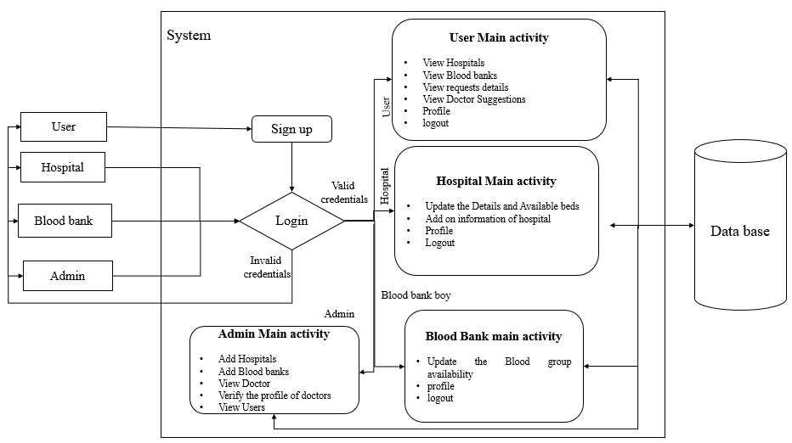

**Figure 4.4 Architecture Design**

**4.5** **Software Development Life Cycle**

The term "Agile" embodies the concepts of speed and adaptability. The Agile process model is a software development methodology focused on iterative development. In this framework, tasks are divided into smaller, manageable iterations or phases, eliminating the need for extensive, long-term planning. Initially, the scope and requirements of the project are outlined, including the number of iterations, their duration, and the objectives for each phase.

Each iteration serves as a short "time frame" within the Agile model, generally lasting between one and four weeks. Breaking the project into smaller parts reduces risks and accelerates delivery timelines. During each iteration, the development team completes the entire software development life cycle—including planning, analyzing requirements, designing, coding, testing—and delivers a functional product to the client.

The Agile model encompasses various methodologies, each adhering to shared principles but differing slightly in execution. Common Agile software development life cycle (SDLC) models include:

* Crystal
* Feature-Driven Development (FDD)
* Scrum
* Extreme Programming (XP)
* Lean Development
* Unified Process

In this approach, requirements are divided into smaller, incremental units that can be developed and delivered iteratively. Each unit is planned, created, and deployed as an independent deliverable, ensuring that development tasks remain small and manageable within short timeframes.

Agile blends iterative and incremental methods. The essential stages of Agile SDLC models are:

* Requirement Gathering
* Requirement Analysis
* Design
* Coding
* Unit Testing
* Acceptance Testing

A critical feature of Agile is the concept of the "Time Box," which sets the maximum duration for delivering an iteration to the customer. The iteration's deadline is fixed to ensure timely delivery. If necessary, the scope of functionality delivered can be adjusted to meet the timeline. A central tenet of Agile development is delivering functional increments to customers after each iteration.

By leveraging the Agile approach, development teams benefit from enhanced flexibility, quicker feedback loops, and ongoing improvements, resulting in a product that better aligns with customer expectations.

.

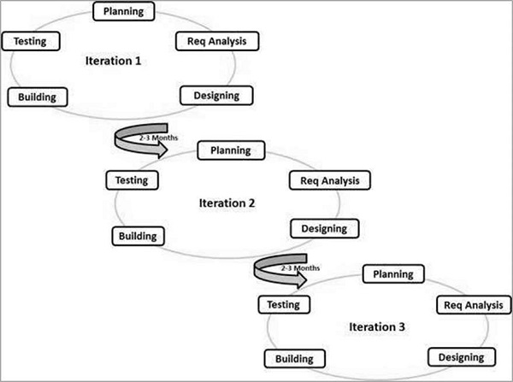

**Figure 4.5.1 Agile Model**

## PRINCIPLES OF AGILE MODEL

## To promote a clear understanding of project requirements and foster close collaboration, a customer representative actively participates as part of the development team. After each iteration, stakeholders and the customer representative evaluate the progress and revisit the requirements to ensure alignment with the project's goals.

## Agile prioritizes deploying functional software over producing extensive documentation.

## The model emphasizes delivering incremental versions of the software to customers frequently, often within intervals of a few weeks.

## Change requests from customers are welcomed and implemented efficiently to accommodate evolving requirements.

## Agile focuses on team efficiency and highlights the importance of effective communication. Face-to-face interactions are preferred over formal document exchanges to ensure better collaboration.

## Teams are generally kept small, ideally between 5 to 9 members, to facilitate face-to-face communication and promote a collaborative working environment.

## Agile development often employs Pair Programming, where two developers work at the same workstation. One writes the code while the other reviews it in real time, and they switch roles periodically, typically every hour.

## Advantages:

## Pair Programming results in well-structured, compact code with fewer errors compared to individual programming efforts.

## Development time is reduced as customers can evaluate incremental versions of the software after each iteration, allowing them to suggest changes as needed.

## Disadvantages:

## The absence of comprehensive documentation can cause confusion and misinterpretations of important decisions across different team members during the project.

## Maintenance of the project may become challenging once it is completed, especially if developers are reassigned to other tasks, due to a lack of formal documentation.

## SOFTWARE ENVIRONMENT

## The software environment refers to the platform on which applications are developed and executed.

## Android is a software stack designed for mobile devices, which includes an operating system, middleware, and core applications. Google Inc. acquired the initial developer, Android Inc., in 2005.

## Android's operating system is built on the Linux kernel. It is collaboratively developed by Google and other members of the Open Handset Alliance. The Android Open-Source Project (AOSP) manages the platform's ongoing development and maintenance. Today, Android is the most widely used smartphone operating system worldwide.

## The Android Software Development Kit (SDK) provides the tools and APIs required for developing applications on the Android platform using the Java programming language. Android boasts a large community of developers who create applications, or "apps," that extend device functionality. Currently, the platform supports over 250,000 applications.

## Key Features of Android:

## Application framework that supports reuse and replacement of components.

## Dalvik virtual machine optimized for mobile devices.

## Integrated browser built on the open-source WebKit engine.

## Enhanced graphics with a custom 2D graphics library and optional 3D graphics using OpenGL ES 1.0.

## SQLite for structured data storage.

## Media support for standard formats such as MPEG4, H.264, MP3, AAC, AMR, JPG, PNG, and GIF.

## Support for GSM Telephony (hardware dependent).

## Connectivity options including Bluetooth, EDGE, 3G, and Wi-Fi (hardware dependent).

## Hardware integration for Camera, GPS, compass, and accelerometer.

## Robust development environment that includes a device emulator, debugging tools, performance profiling tools, and an Eclipse IDE plugin for Android development.

## ANDROID ARCHITECTURE

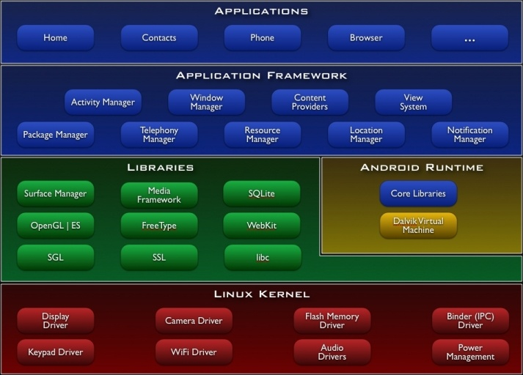**Figure 4.5.2 Android Architecture**

## LIBRARIES

### Android Core Libraries

### Android includes a collection of C/C++ libraries utilized by various components within the system. These libraries are accessible to developers via the Android application framework. The key libraries include:

### System C Library - A BSD-based implementation of the standard C system library (libc), optimized for Linux-based embedded devices.

### Media Libraries - Based on OpenCORE by Packet Video, these libraries facilitate playback and recording of popular audio and video formats, including MPEG4, H.264, MP3, AAC, AMR, JPG, and PNG.

### Surface Manager - Manages the display subsystem and enables seamless composition of 2D and 3D graphical layers from multiple applications.

### LibWebCore - A modern web browser engine powering the Android browser and embeddable web views.

### SGL - The core 2D graphics engine.

### 3D Libraries - OpenGL ES 1.0 APIs provide support for 3D graphics. These libraries utilize hardware 3D acceleration (when available) or a highly optimized 3D software rasterizer.

### FreeType - Supports bitmap and vector font rendering.

### SQLite - A robust, lightweight relational database engine available for all applications.

### Android Runtime

### The Android runtime includes a set of core libraries providing functionality similar to the core libraries in Java. Each Android application operates within its own process and its own instance of the Dalvik Virtual Machine (DVM).

### The Dalvik VM is designed for efficient multitasking and optimized memory usage.

### Applications are executed in Dalvik Executable (.dex) format, generated from standard Java bytecode using the dx tool.

### The Dalvik VM is register-based and relies on the Linux kernel for underlying functions such as threading and memory management.

### Linux Kernel

### Android runs on a customized version of the Linux 2.6 kernel, which provides essential system services, including:

### Security

### Memory management

### Process management

### Networking

### Driver model

### The Linux kernel acts as a hardware abstraction layer between the Android system and the underlying hardware. It is one of the most widely used examples of free and open-source software, developed under the GNU General Public License version 2 (GPLv2).

### History: The Linux kernel was created by Linus Torvalds in 1991 and has grown with contributions from thousands of developers worldwide.

### Role in Android: The kernel enables Google to provide a flexible and upgradeable platform. Android's reliance on the kernel allows for better hardware and software integration.

### Android Hardware

### Android primarily supports devices based on the ARM architecture but can also run on devices powered by Intel x86 or PowerPC architectures.

### Android powers cellphones, tablets, netbooks, smart TVs, and more. Examples include the HTC Dream (first Android phone, 2008) and Google's Nexus series (Nexus One, Nexus S).

### Android SDK (Software Development Kit)

### The Android SDK provides a comprehensive suite of tools for developing Android applications, including:

### A debugger

### Libraries

### Emulator (based on QEMU)

### Documentation

### Sample code and tutorials

### Supported Platforms:

### Linux (modern distributions)

### Mac OS X (10.4.9 or later)

### Windows (XP or later)

### Development Environments:

### The recommended IDE is Eclipse with the Android Development Tools (ADT) plugin. However, developers can use any text editor and command-line tools (e.g., JDK and Apache Ant).

### Application Package:

### Android applications are packaged in the .apk format.

### The APK contains .dex files (Dalvik Executable), resource files, and other application assets.

### APKs are stored in the /data/app folder, accessible only to the root user for security.

### Android Operating System Overview

### Android is an operating system built on Linux, featuring a Java programming interface. Key characteristics include:

### Virtual Machine:

### Android uses the Dalvik Virtual Machine (DVM), optimized for embedded systems.

### Java bytecode is converted to Dalvik bytecode (dex format) using the dx tool.

### APK files are generated with the Android Asset Packaging Tool (aapt).

### Graphics:

### Android supports 2D and 3D graphics through OpenGL libraries.

### Storage:

### Data storage is managed using a SQLite database.

### Process Isolation:

### Every Android application runs in its own process and is assigned a unique user ID, ensuring isolation between applications.

### Key Components of Android Applications

### An Android application consists of the following components:

### Activity:

### Represents the user interface (UI) of an application.

### Applications can have multiple activities, allowing navigation between screens.

### Views:

### The UI components of activities are built using widgets that extend from android view.View.

### Layouts are managed using android.view.ViewGroups.

### Services:

### Perform background operations without a UI.

### Can notify users via the Android notification framework.

### Content Provider:

### Allows applications to share data with other applications.

### SQLite databases can serve as data providers.

### Intents:

### Enable communication between activities and services.

### Explicit Intents: Directly call specific components.

### Implicit Intents: Request components capable of performing a task (e.g., opening a contact application).

### Broadcast Receiver:

### Responds to system-wide broadcasts or implicit intents.

### Applications can register to listen for specific events (e.g., battery level changes).

### Java Virtual Machine (JVM) and Android

### While Android uses the Dalvik Virtual Machine, the JVM concept underpins Android's core principles:

### WORA (Write Once, Run Anywhere): The JVM enables Java programs to run on different platforms without modification.

### Execution Model:

### Java programs are compiled into portable bytecode (.class files).

### These files are executed by the JVM, either through interpretation or Just-In-Time (JIT) compilation for optimized performance.

### Bytecode can also be precompiled into native code using Ahead-of-Time compilers.

### Standard Libraries:

### JVM distributions include libraries implementing the Java API, bundled into the Java Runtime Environment (JRE).

### JVM supports automated exception handling and debugging features.

### Setting Up the Android SDK

### To get started with Android development, follow these steps:

### System Preparation:

### Ensure your computer meets the system requirements (e.g., JDK installation).

### Install the SDK Starter Package:

### Download the installer (Windows) or the SDK package for Linux/Mac.

### Install ADT Plugin for Eclipse:

### Install Eclipse (recommended version: Eclipse Classic) and add the ADT plugin using the update URL: https://dl-ssl.google.com/android/eclipse/.

### Add Android Platforms and Components:

### Use the Android SDK and AVD Manager to install platforms and necessary tools.

### Explore the SDK:

### Review the documentation, sample code, and available tools.

### By following these steps, developers can efficiently set up their development environment and begin building robust Android applications.

### Configuration

In Eclipse open the Preferences dialog via Windows -> Preferences. Select Android and maintain the installation path of the Android SDK.

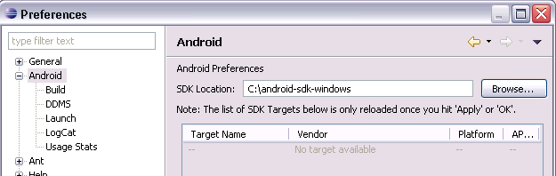

**Figure 4.5.3 Installation Path of the Android SDK**

**Step1**: **Select Window -> Android SDK and AVD Manager from the menu**.

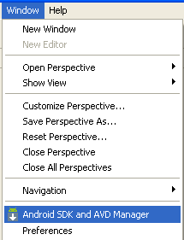

Select available packages and select the latest version of the SDK.

**Step 2: Downloading the SDK Starter Package**

The SDK starter package provides only the essential SDK Tools, which are required to download additional components like the latest Android platform. It does not include a complete development environment.

1. **Obtain the Latest SDK Starter Package**:  
   If you haven't already, download the most recent version of the SDK starter package from the official SDK download page.
2. **For .zip or .tgz Packages**:
   * If you downloaded a .zip or .tgz file, extract its contents to a secure location on your system.
   * By default, the extracted files are placed in a directory named android-sdk-<machine-platform>.
3. **For Windows Installer (.exe)**:
   * If you downloaded the .exe installer, run it.
   * The installer will check whether the Java SE Development Kit (JDK) is present on your system. If the JDK is missing, the installer will prompt you to install it before proceeding.
   * The SDK Tools will then be installed into a default directory, though you can customize the installation path if needed.
4. **Take Note of the SDK Directory**:
   * After the installation, make note of the directory where the SDK has been installed.
   * You will need this path when configuring the ADT plugin or running SDK tools via the command line.

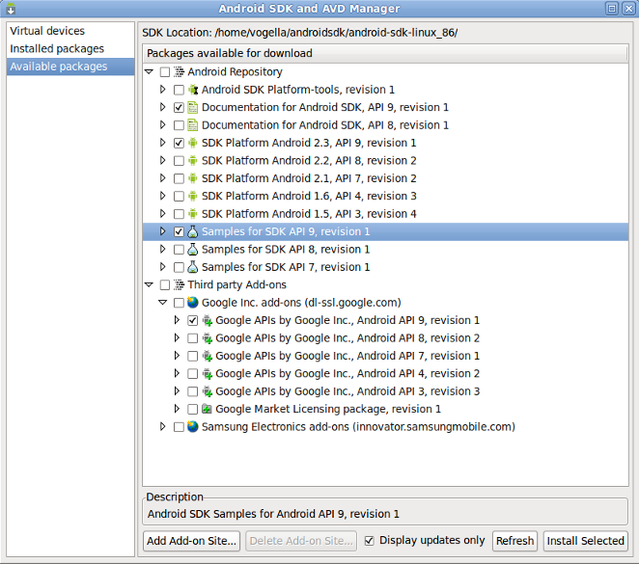

**Figure 4.5.4 SDK Starter Package Download**

**Step 3: Installing the ADT Plugin for Eclipse**

Android provides a dedicated plugin for the Eclipse IDE known as Android Development Tools (ADT). This plugin offers a robust and integrated environment to streamline Android application development. ADT enhances Eclipse's functionality, enabling you to:

Quickly set up new Android projects.

* Design and develop application user interfaces.
* Debug applications using the Android SDK tools.
* Export both signed and unsigned APKs for application distribution.

Using Eclipse with the ADT plugin is highly recommended as it simplifies the development process and is one of the fastest ways to start building Android applications.

**Installing the ADT Plugin:**

If you plan to use ADT for your Android development, install it now. Refer to the detailed instructions in the Installing the ADT Plugin guide, and once completed, return here to proceed with the final step of setting up your Android SDK.

**Alternative Development Environments:**

If you prefer working in an IDE other than Eclipse, you are not required to install Eclipse or the ADT plugin. Instead, you can directly utilize the SDK tools to build and debug your applications. For more details, the Introduction to Android Application Development guide outlines the essential steps involved in developing Android applications in Eclipse or alternative IDEs.



**Figure 4.5.5 ADT Plugin for Eclipse Installation**



**Figure 4.5.6 Utilizing the SDK tools**

**Step 4: Adding Platforms and Additional Components**

The final step in setting up your Android SDK involves using the Android SDK and AVD Manager—a tool included with the SDK starter package—to download and integrate essential components into your development environment.

The Android SDK follows a modular design, which organizes the key parts of the SDK into separately installable components. These components include:

* Android platform versions
* Add-ons
* SDK tools
* Samples
* Documentation

The SDK starter package you have already downloaded contains only one component: the latest version of the SDK Tools. However, to develop Android applications, you must download at least one Android platform version along with its corresponding platform tools. It is highly recommended to include additional platforms and components to ensure a comprehensive development setup and better flexibility in building and testing your applications.



**Figure 4.5.7 Adding Platforms and Components**



**Figure 4.5.8 Installing Archives**

* When you complete the Windows installer, the **SDK and AVD Manager** will launch automatically, preselecting a recommended set of platforms and components for installation. Simply click **Install** to accept and install the suggested components. Once installed, you can proceed to the next step. However, it is recommended to review the **Available Components** section to better understand what is included.
* **Launching the Android SDK and AVD Manager**
* You can open the **SDK and AVD Manager** in one of these ways:
* **From Eclipse**: Go to Window > Android SDK and AVD Manager.
* **On Windows**: Run the SDK Manager.exe file in the root directory of the SDK.
* **On Mac or Linux**: Open a terminal, navigate to the tools/ directory within the SDK folder, and run the following command:
* Once launched, use the graphical interface of the SDK and AVD Manager to browse through the SDK repository and select new or updated components (see figure 1). These components are installed directly into your SDK environment. Refer to the **Recommended Components** section for guidance on what to download.
* **Types of Components in the Android Repository**
* The **Android Repository** offers several components, such as:
* **SDK Tools**  
  These are essential tools for debugging, testing, and other utility operations. They are included in the starter package and are periodically updated. Access these tools in the <sdk>/tools/ directory. Learn more in the *SDK Tools* section of the developer guide.
* **SDK Platform-tools**  
  Platform-dependent tools that support application development and debugging. These tools are updated alongside new platform releases and can be found in the <sdk>/platform-tools/ directory. Refer to the *Platform Tools* section of the developer guide for more details.
* **Android Platforms**  
  Each Android version has its corresponding SDK platform. These components include the Android library, system images, sample code, and emulator skins. For specific platform details, review the *Downloadable SDK Components* section.
* **USB Driver for Windows**.  
  These drivers allow Windows users to connect and debug applications on actual Android devices. Mac OS X and Linux users do not need this driver for device debugging. More details can be found under *Using Hardware Devices*.
* **Samples**  
  Sample code and applications are provided for each Android platform. Beginners are encouraged to download these samples to aid their development process.
* **Documentation**  
  This component provides a local copy of the most recent multi-version Android API documentation.
* **Third-Party Add-ons**
* Third-party add-ons allow you to integrate external libraries (e.g., the Google Maps library) or use customized, fully compliant Android system images. You can add more repositories by clicking on **Add Add-on Site** in the SDK and AVD Manager.
* **Eclipse Overview**
* **Eclipse** is an open-source community that delivers an extensible platform for software development, deployment, and lifecycle management. While primarily recognized as a Java IDE, Eclipse supports a wide range of programming languages and frameworks, making it far more versatile.
* The Eclipse ecosystem consists of over 60 open-source projects grouped into seven main categories:
* **Enterprise Development**
* **Embedded and Device Development**
* **Rich Client Platform**
* **Rich Internet Applications**
* **Application Frameworks**
* **Application Lifecycle Management (ALM)**
* **Service-Oriented Architecture (SOA)**
* Eclipse is supported by a diverse community, including IT solution providers, start-ups, universities, and individual developers who contribute extensions and tools to enhance the platform.
* **Key Features of Eclipse**
* Eclipse offers a multi-language development environment built on a plug-in system. It primarily supports Java but can extend to other programming languages such as:
* **C, C++, COBOL, PHP, Perl, Python, Ruby (including Rails), Scala, Ada, Clojure, and Scheme.**
* Eclipse's versatility comes from its architecture, which allows any plug-in to integrate seamlessly with the platform. Major features include:
* **Java Development Tools (JDT)**: An incremental Java compiler and full support for source code analysis and refactoring.
* **Workspace Model**: A flexible file management system supporting external file modifications with resource synchronization.
* **SWT and JFace**: Provides advanced tools for GUI creation using the *Standard Widget Toolkit (SWT)* and simplified *JFace* viewers.
* **Rich Client Platform (RCP)**
* Eclipse's **RCP** allows developers to build desktop applications using:
* **Equinox OSGi**: A standard bundling framework.
* **Core Platform**: Manages booting and running plug-ins.
* **SWT**: A portable and efficient widget toolkit.
* **JFace**: Provides MVC programming support for SWT with tools for text handling, buffers, and editors.
* **Workbench**: Includes tools for views, editors, perspectives, and wizards.
* **Plug-in Architecture**
* Eclipse operates on a lightweight plug-in framework, allowing integration with various tools like LaTeX, database systems, and networking applications. The SDK includes native support for Java and CVS, while Subversion and other tools are available as third-party plug-ins.
* Overall, Eclipse delivers a robust platform for developers to build, manage, and innovate across multiple domains, making software development efficient and highly customizable.

**CHAPTER-5**

**OBJECTIVES**

**1. Centralization of Healthcare Data**

The primary goal of centralizing healthcare data is to eliminate the fragmented nature of traditional systems where information is scattered across various sources. By integrating details such as hospital bed availability, blood bank stocks, and doctor profiles into a single platform, the system ensures that users can access all necessary information in one place. This reduces the time and effort needed to gather critical data, making the healthcare process more streamlined and efficient.

**2. Real-Time Resource Tracking**

In healthcare, especially during emergencies, delays in accessing accurate information can be life-threatening. For instance, if someone needs immediate blood transfusion or emergency hospitalization, the platform provides up-to-date information on where the required resources are available. This minimizes response times and ensures that medical resources are utilized effectively, avoiding situations where patients are denied care due to misinformed decisions.

**3. Enhanced Accessibility and Transparency**

This objective is about making healthcare services more user-friendly and trustworthy. By providing verified doctor profiles and accurate details about hospitals and blood banks, the platform ensures that users can rely on the information they access. For example, patients can confidently choose a hospital or doctor knowing that the information provided is accurate and verified, reducing anxiety and confusion during critical moments.

**4. Optimized Emergency Response**

Emergencies demand quick actions, and the platform is designed to facilitate that by offering tools to locate the nearest medical facilities with the required resources. For example, during an accident or sudden health crisis, users can use the platform to immediately find a hospital with available beds or locate a blood bank with the required blood type. By reducing the time spent searching for resources, the platform helps in delivering timely care, potentially saving lives and improving outcomes in emergency scenarios.

**CHAPTER-6**

**SYSTEM DESIGN & IMPLEMENTATION**

**6.1 Introduction to Input Design**

Input Design serves as the connection between the user and the information system. It involves creating specifications and procedures to prepare data for processing. This data can either be read by the computer from a written or printed document, or it can be directly entered into the system by users. Input design aims to minimize the amount of input, reduce errors, avoid unnecessary delays or steps, and keep the process simple. A well-designed input process ensures ease of use, security, and privacy. Key considerations in input design include:

* What data should be provided as input?
* How should the data be arranged or encoded?
* Providing clear guidance to the operating personnel for input entry.
* Preparing input validation methods and handling errors when they occur.

Objectives of Input Design:

* The main goal of input design is to transform a user-focused description of input into a computer-friendly system. This minimizes errors and ensures that management receives accurate information for decision-making.
* User-friendly data entry screens are created to handle large data volumes efficiently, making data entry seamless and error-free. The screen designs also support data manipulations and record viewing.
* During data entry, validation checks ensure accuracy. User-friendly prompts and appropriate messages help users avoid confusion.
* The ultimate objective is to create an easy-to-follow input layout that enhances usability and accuracy.

**6.1.1 Output Design**

High-quality output is essential as it delivers clear, accurate, and usable information to the end user. Outputs are the results of processing data and can be presented immediately or as a printed hard copy. Well-designed outputs enhance system usability, assist users in decision-making, and improve user satisfaction.

**6.1.2 Principles of Output Design:**

1. Organized Development: Outputs should be planned systematically to meet user requirements while ensuring the system is easy to use.
2. Information Presentation: Selecting effective methods for presenting the data.
3. Formats and Reports: Creating documents, reports, or formats containing the generated information.

Objectives of Output Design:  
The output design of a system must achieve the following:

* Convey information about past activities, current statuses, or future projections.
* Highlight significant events, problems, opportunities, or warnings.
* Initiate or confirm actions.
* Prompt users to take specific actions.

**6.2 UML Diagram**

UML (Unified Modeling Language) is a standardized, general-purpose modeling language used in object-oriented software engineering. Developed and managed by the Object Management Group (OMG), UML provides a common framework for visualizing, specifying, constructing, and documenting software systems and business processes.

UML combines best engineering practices to effectively model complex and large-scale systems. It primarily uses graphical notations to represent various components of software projects, simplifying communication and design.

**6.2.1 Goals of UML:**

1. Provide a user-friendly and expressive visual modeling language for creating and exchanging meaningful models.
2. Enable extendability and customization of the core concepts.
3. Maintain independence from specific programming languages and development processes.
4. Establish a formal foundation for understanding the modeling language.
5. Promote the growth of object-oriented tool markets.
6. Support higher-level development concepts such as frameworks, components, patterns, and collaborations.
7. Integrate and promote best software engineering practices.

**6.2.2 Use Case Diagram**

A Use Case Diagram in UML is a behavioral diagram that provides a visual representation of the system's functionality. It identifies the actors, their goals, and the interactions with the system in terms of use cases.

The primary purpose of a use case diagram is to illustrate the functionalities provided by the system and the roles of actors involved. It provides a high-level overview of what the system does and for whom.

Key components of a use case diagram include:

* Actors: Represent external entities (users, systems) interacting with the system.
* Use Cases: Define the specific functionalities or processes provided by the system.
* Relationships: Show dependencies or connections between use cases and actors.

Use case diagrams help stakeholders and developers understand the system’s behavior and identify key requirements efficiently.

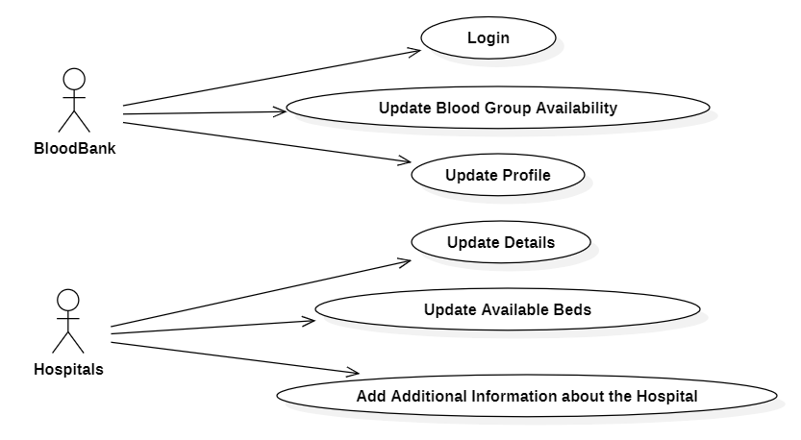

**Figure 6.2.1 Hospital Use Case Diagram**

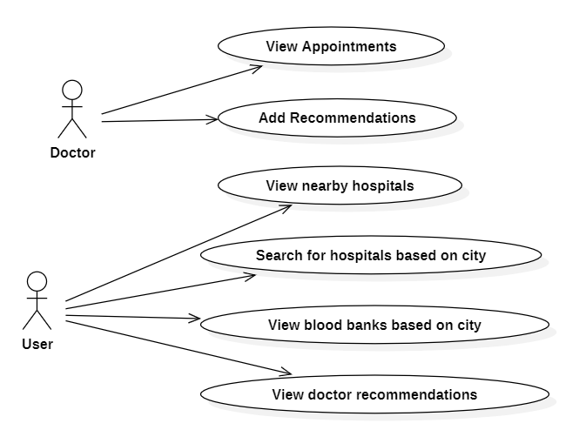

**Figure 6.2.2 User and Doctor Use Case Diagram**

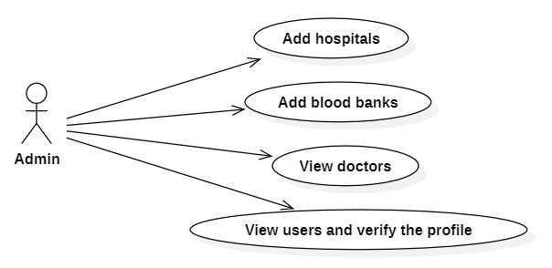

**Figure 6.2.3 Admin Use Case Diagram**

**6.2.3 Class Diagram:**

A **Class Diagram** in software engineering, specifically in the Unified Modeling Language (UML), is a type of static structure diagram that represents the structure of a system. It illustrates the various classes within the system, along with their **attributes** (data), **operations** (methods), and the **relationships** between these classes. The diagram serves to detail which class holds certain information and how different classes are interconnected.

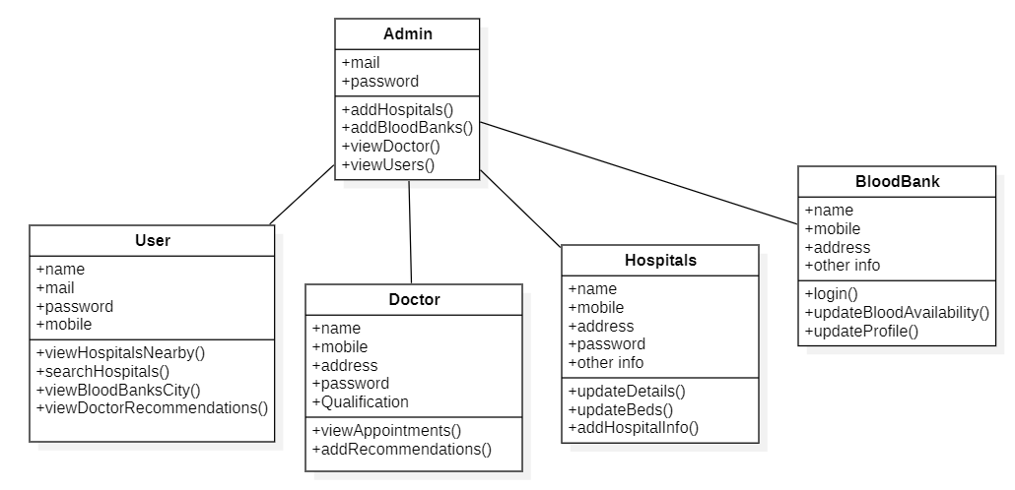

**Figure 6.2.4 Class Diagram**

**6.2.4 Sequence Diagram:**

A **Sequence Diagram** in Unified Modeling Language (UML) is a type of interaction diagram that illustrates how processes interact with each other in a specific order. It represents the sequence of messages exchanged between objects or components in the system, highlighting the order in which these messages occur. Sequence diagrams are often referred to as event diagrams, event scenarios, or timing diagrams.

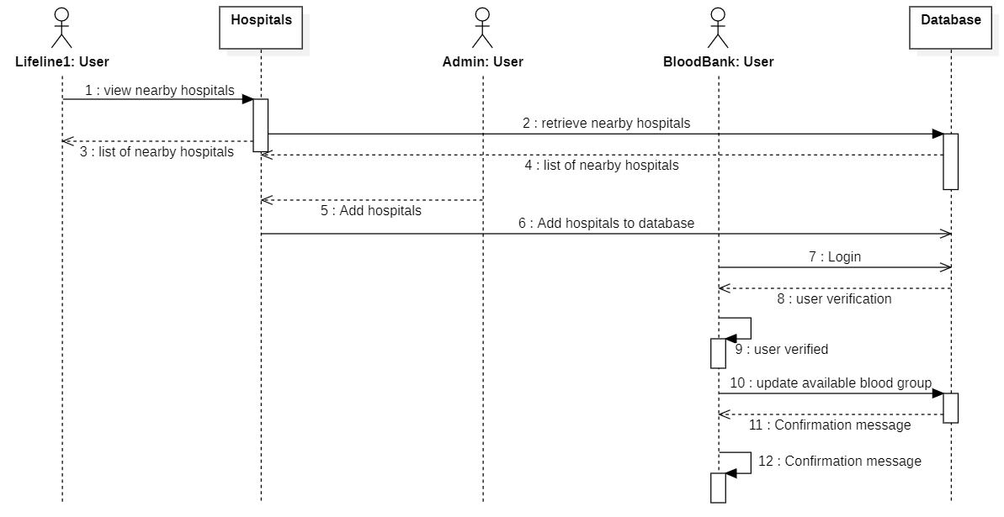

**Figure 6.2.5 Sequence Diagram**

**6.2.5 Collaboration Diagram:**

In a **Collaboration Diagram**, the sequence of method calls is indicated using a numbering technique that shows the order in which methods are invoked. These numbers represent the sequential flow of method calls, similar to a **Sequence Diagram**. However, the key difference lies in the way the diagrams are presented: while a sequence diagram focuses on the order of messages and interactions over time, a collaboration diagram emphasizes the organization of the objects involved in the interaction.

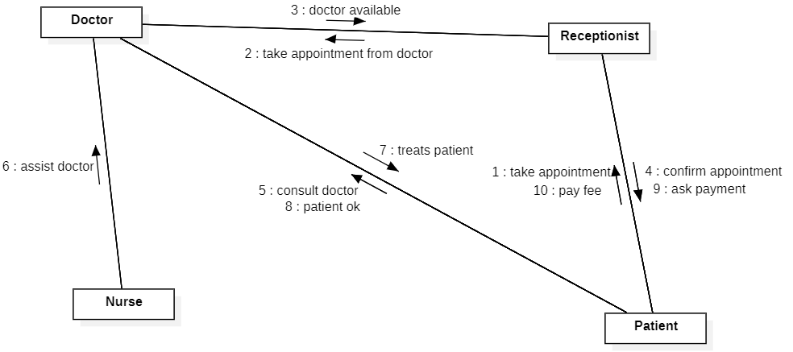**Figure 6.2.6 Collaboration Diagram**

**6.2.6 Activity Diagram:**

**Activity Diagrams** are graphical representations used to depict the flow of control in a system through stepwise activities and actions. They are particularly useful for modeling workflows that involve choices, iterations, and concurrency. In the context of the Unified Modeling Language (UML), activity diagrams are commonly used to describe the step-by-step workflows of business processes or the operations of component.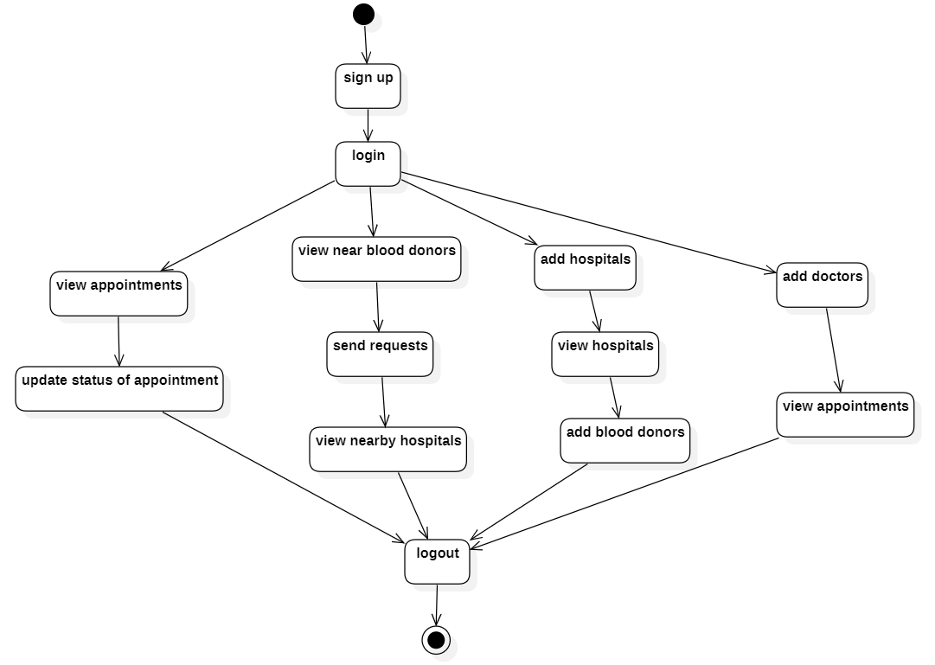

**Figure 6.2.7 Activity Diagram**

**6.2.7 Component Diagram:**

A **component diagram** is a type of UML (**Unified Modeling Language**) diagram that illustrates the organization and dependencies among components in a system. It focuses on the structural aspects of software architecture by showing how different software components interact with each other and with the system's environment.

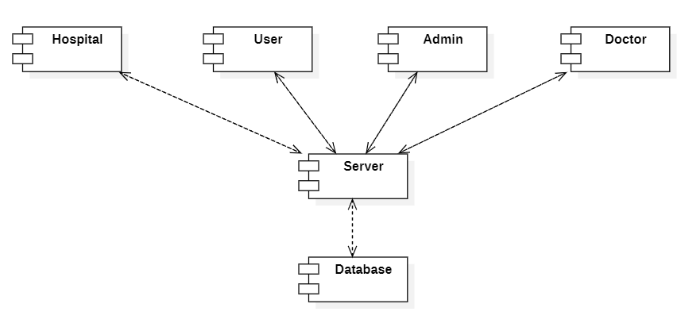

**Figure 6.2.8 Component Diagram**

**6.2.8 Deployment Diagram:**

A **Deployment Diagram** is a type of UML (**Unified Modeling Language**) diagram that represents the physical deployment of artifacts (software components, files, executables, etc.) on hardware nodes in a system. It focuses on the hardware and software infrastructure and how software components are distributed across physical or virtual environments.



**Figure 6.2.9 Deployment Diagram**

**6.2.9 ER Diagram:**

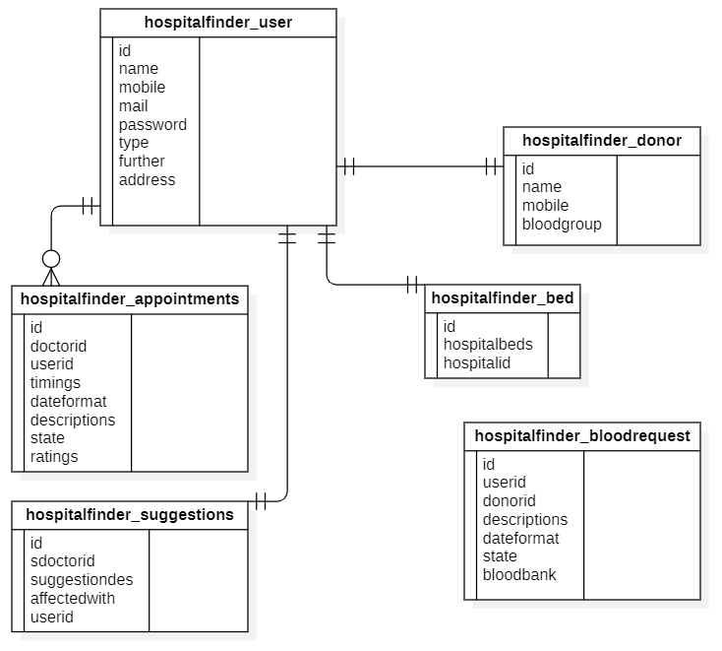

**Figure 6.2.10 ER Diagram**

**6.3 Data Flow Diagram:**

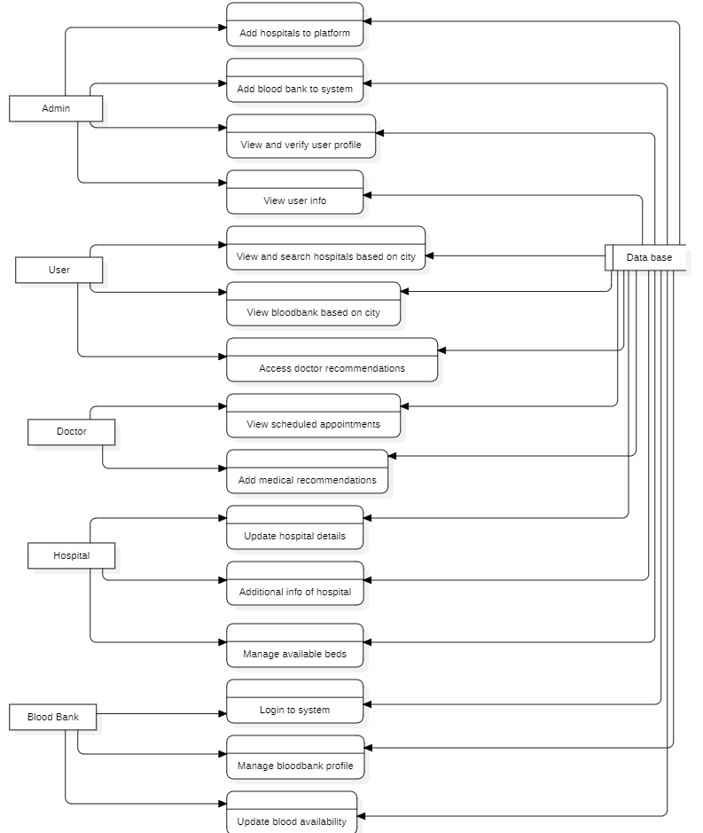

**Figure 6.2.11 Data Flow Diagram**

**6.4 Implementation**

The implementation phase involves translating the planned modules and features into a fully functional system. This phase ensures that each stakeholder—administrators, doctors, blood banks, specialist doctors, and users—can seamlessly interact with the platform. Each module is designed to cater to specific roles, offering tailored functionalities to optimize the overall blood donation process.

**6.4.1 Admin Module**

The Admin Module serves as the backbone of the platform, granting administrators complete control over its operations. This module provides robust functionality to manage key aspects such as donor registration, user requests, and data management.

**Key Features of the Admin Module:**

* **Donor Management**: Administrators can add, update, or remove donor profiles from the system. This ensures that the database remains accurate and up to date, facilitating efficient matching during emergencies.
* **User Requests**: Admins can monitor and oversee user-generated requests for blood. The module includes features for verifying and prioritizing these requests based on urgency, ensuring timely allocation of resources.
* **Doctor and Blood Bank Management**: Administrators can access and manage details of registered doctors and blood banks. This includes approving new registrations, updating profiles, and ensuring active participation from these entities.
* **Reports and Insights**: The module is equipped with tools to generate reports on donor activities, blood bank contributions, and user engagement metrics. This allows the admin to make data-driven decisions for improving the platform’s effectiveness.

This module acts as a centralized hub, enabling administrators to ensure smooth coordination among all stakeholders and maintain the platform's efficiency.

**6.4.2 Doctor Module**

The Doctor Module is designed specifically for medical professionals, allowing them to actively engage with the platform. This module simplifies the process for doctors to register, manage their availability, and provide input when needed.

**Key Features of the Doctor Module:**

* **Registration and Login**: Doctors can create accounts by providing essential details such as name, qualifications, contact information, and specialization. The login functionality ensures secure access to the platform.
* **Availability Management**: Doctors can update their availability status in real time. This feature helps administrators and users identify active doctors who can be contacted for consultations or assistance.
* **Communication**: Doctors can interact with administrators and other stakeholders through secure messaging or notification systems, ensuring clear and direct communication.

This module empowers doctors to play an active role in the healthcare ecosystem, streamlining their contributions to the blood donation process.

**6.4.3 Blood Bank Module**

The Blood Bank Module is tailored for blood banks, enabling them to efficiently manage their activities and update their available resources. This module is critical for maintaining a reliable and accessible database of blood supplies.

**Key Features of the Blood Bank Module:**

* **Registration and Login**: Blood banks can create accounts by providing organizational details such as location, contact information, and licensing details. This ensures that only verified entities are part of the platform.
* **Profile Management**: Blood banks can manage their profiles and update key information, such as operating hours and services offered.
* **Inventory Updates**: The module allows blood banks to update the availability of different blood groups in real time. This ensures that the platform can provide users with accurate and up-to-date information.
* **Collaboration**: Blood banks can coordinate with administrators and other stakeholders to ensure effective management of blood donation drives and resources.

By integrating this module, the platform facilitates efficient resource allocation and minimizes the time required to find compatible donors during emergencies.

**6.4.4 User Module**

The User Module serves as the primary interface for individuals seeking to engage with the platform. Designed with simplicity and accessibility in mind, this module ensures that users can easily navigate the system and access the services they need.

**Key Features of the User Module:**

* **Registration and Login**: Users can create accounts by providing basic details such as name, age, contact information, and blood group. Secure login functionality ensures data privacy.
* **Search and Request**: Users can search for available donors or blood banks based on their location and blood group requirements. They can also submit requests for blood, which are routed to the admin for verification and processing.
* **Access to Doctors and Blood Banks**: Users can view a list of nearby doctors and blood banks, along with their contact details and availability.
* **Notifications and Alerts**: The module sends notifications to users about the status of their requests, upcoming blood donation drives, and other relevant updates.

This module fosters user engagement, making it easy for individuals to find the resources they need and contribute to the blood donation ecosystem.

**6.4.5 Specialist Doctors (SDoctors) Module**

The Specialist Doctors Module is a unique feature designed to facilitate the contributions of specialist doctors, such as haematologists and surgeons, to the platform. This module enhances knowledge sharing and collaboration among healthcare professionals.

**Key Features of the Specialist Doctors Module:**

* **Registration and Login**: Specialist doctors can register by providing detailed credentials, including their area of expertise and certifications. Secure login functionality ensures that only authorized personnel have access.
* **First-Aid Contributions**: Specialist doctors can contribute valuable first-aid information and guidelines, which are made accessible to users through the platform. This feature promotes public awareness and education.
* **Suggestions and Monitoring**: The module allows specialist doctors to provide suggestions for improving the platform and monitor ongoing activities. Their feedback helps refine the system’s functionality and effectiveness.
* **Collaboration**: The module facilitates communication and collaboration between specialist doctors, general practitioners, and administrators, fostering a cohesive healthcare ecosystem.

By integrating this module, the platform leverages the expertise of specialist doctors to enhance the overall quality and reliability of its services.

**CHAPTER-7**

**TIMELINE FOR EXECUTION OF PROJECT**

**(GANTT CHART)**

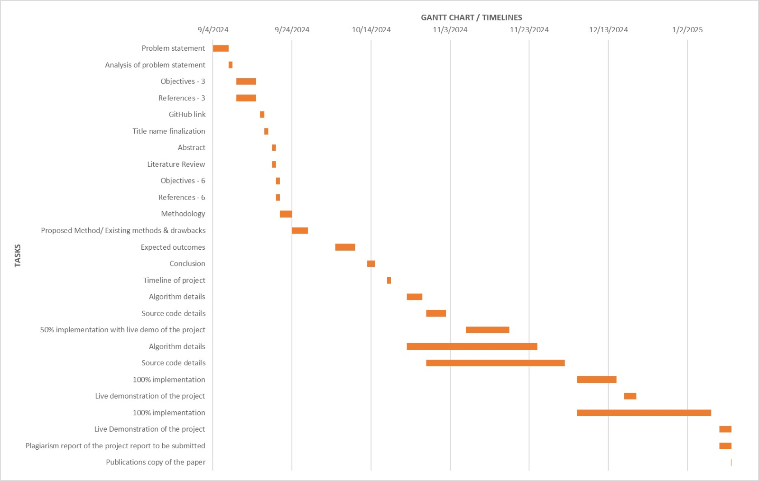

**Figure 7.1 Gantt Chart**

**CHAPTER-8**

**OUTCOMES**

The implementation of the proposed digital healthcare platform is expected to yield significant outcomes that enhance the efficiency, transparency, and accessibility of healthcare services. The anticipated results are outlined below:

**1.** **Improved Accessibility to Medical Resources**. The centralized platform ensures that users, including patients and healthcare providers, can access real-time information about hospital bed availability, blood bank inventory, and doctor profiles. This improved accessibility leads to faster decision-making and reduces delays in obtaining critical medical services.

**2. Enhanced Efficiency in Healthcare Operations**. By replacing manual processes with a digitized system, the platform eliminates inefficiencies such as data duplication, miscommunication, and delays caused by outdated methods. Healthcare facilities can streamline their operations, leading to optimized resource utilization and better service delivery.

**3. Real-Time Updates for Timely Care**. The real-time update feature ensures that patients and caregivers receive accurate information during emergencies. This reduces the time spent locating medical resources and enables quicker responses, ultimately saving lives in critical situations.

**4. Transparency and Trust Among Users**. The system promotes transparency by offering verified doctor recommendations, accurate data, and administrative oversight. This fosters trust between healthcare providers and patients, ensuring a more reliable and confident healthcare experience.

**5. Empowered Administration**. Healthcare administrators gain tools to manage and oversee data, onboard entities, and verify information. This empowers them to maintain the accuracy and integrity of the system, leading to a well-regulated and efficient healthcare ecosystem.

**6. Reduced Burden on Emergency Services**. By providing real-time resource tracking and reducing miscommunication, the platform alleviates the pressure on emergency services. Patients are directed to the most appropriate facilities, ensuring balanced distribution of healthcare resources.

**7. Higher Patient Satisfaction**. Patients benefit from quicker access to services, trustworthy doctor recommendations, and a simplified process for finding medical care. This leads to an overall improvement in patient satisfaction and confidence in the healthcare system.

**8. Scalable Model for Future Integration**. The platform serves as a scalable model that can be expanded to include additional features such as telemedicine, AI-based diagnostics, and integration with wearable health devices. This paves the way for continuous innovation and improvement in healthcare technology.

**CHAPTER-9**

**RESULTS AND DISCUSSIONS**

**9.1 Stakeholder Involvement**

* Healthcare Providers:
  + Collaboration with hospitals, clinics, and blood banks to integrate their real-time data.
  + Establishing trust and commitment from healthcare professionals for accurate and regular updates.
* Government and Regulators:
  + Addressing legal and compliance requirements, such as patient data privacy (HIPAA, GDPR).
  + Gaining support to fund and scale the platform.
* End Users:
  + Ensuring the application caters to patients, caregivers, and healthcare workers' needs.
  + Gathering user feedback to improve usability and functionality.

**9.2 Technical Considerations**

* Real-Time Data Integration:
  + Ensuring seamless API integration with hospital management systems, blood banks, and ambulance services.
  + Addressing challenges related to data synchronization and accuracy.
* Scalability:
  + Designing the system to handle heavy traffic during emergencies or pandemics.
  + Future-proofing the architecture for additional features like telemedicine or predictive analytics.
* Security:
  + Encrypting sensitive patient and hospital data to prevent breaches.
  + Implementing robust authentication mechanisms for both users and administrators.
* Google Maps API Utilization:
  + Leveraging location data efficiently without overloading the user interface.
  + Addressing inaccuracies in mapping during emergencies or in rural areas.

**9.3 Challenges**

* Data Accuracy:
  + Ensuring hospitals and blood banks regularly update their resource availability.
  + Avoiding misinformation that could lead to delays or mistrust in the platform.
* User Adoption:
  + Educating users on how to utilize the app during emergencies effectively.
  + Overcoming resistance from less tech-savvy users or regions with low digital penetration.
* Infrastructure Dependence:
  + The success of the platform relies on robust internet connectivity and smartphone accessibility.
  + Ensuring functionality in low-bandwidth environments.

**9.4 Potential Risks**

* Operational Downtime:
  + Ensuring 24/7 uptime for the platform to handle emergencies.
  + Preparing for unexpected outages or technical glitches.
* Data Privacy Concerns:
  + Mitigating risks of unauthorized data access, which could deter users from adopting the platform.
* Overreliance:
  + Preventing the platform from becoming the sole source of critical data, especially during major disasters.

**9.5 Ethical and Social Impacts**

* Equity in Access:
  + Ensuring the platform is equally accessible to users in rural and urban areas.
  + Addressing disparities in healthcare infrastructure availability across regions.
* User Empowerment:
  + Enabling users to make informed decisions about healthcare during emergencies.
  + Promoting self-reliance rather than complete dependence on intermediaries.

**9.6 Future Directions**

* AI and Predictive Analytics:
  + Incorporating machine learning algorithms to predict hospital resource demands.
  + Offering personalized recommendations based on patient history and location.
* Expanded Features:
  + Telemedicine consultations for non-critical emergencies.
  + Integration with wearable devices for real-time health monitoring.
* Global Reach:
  + Scaling the app to serve international users by accommodating diverse healthcare systems.
  + Adapting to regional languages and cultural sensitivities.

**9.7 Key Metrics for Success**

* User Adoption Rates:
  + Measuring how many patients and caregivers actively use the platform during emergencies.
* Operational Efficiency:
* Reduction in average time taken to find nearby hospitals or blood banks.
* Feedback Scores:
  + Positive user feedback indicating ease of use and reliability.
* Healthcare Outcomes:
* Reduction in preventable deaths and improved emergency response times.

**9.8 Collaborative Opportunities**

* Partnering with non-profits and healthcare organizations for outreach in underserved areas.
* Working with tech giants to improve mapping accuracy and leverage cloud infrastructure.
* Collaborating with educational institutions to promote healthcare literacy and app usage.

**CHAPTER-10**

**CONCLUSION**

**10.1 Conclusion**

The proposed digital healthcare platform represents a significant advancement in improving medical data accessibility, transparency, and operational efficiency. By centralizing critical information related to hospitals, blood banks, and medical professionals, the platform creates a streamlined and reliable system for healthcare services. This centralized approach not only reduces redundancies but also fosters trust among users by ensuring that all data is accurate, up-to-date, and easily accessible. One of the key features of the system is its ability to provide real-time updates, which is crucial in situations where time-sensitive decisions can save lives. For instance, users can quickly locate the nearest hospital or blood bank with available resources, enabling faster responses during emergencies. Additionally, the inclusion of verified doctor insights ensures that patients receive reliable information, which helps in making informed decisions about their healthcare. This builds a bridge of trust between medical professionals and the public, addressing one of the most significant challenges in the healthcare industry—credibility and reliability. From an administrative perspective, the platform offers comprehensive oversight capabilities, allowing for better management of resources and services. Administrators can monitor operations, ensure compliance with standards, and make data-driven decisions to optimize healthcare delivery.

Overall, this digital healthcare platform revolutionizes the way medical services are accessed and managed. By integrating advanced technology, real-time data, and user-friendly interfaces, it transforms traditional healthcare systems into more efficient, reliable, and patient-centric solutions. The platform’s ability to bridge gaps in communication and resource allocation marks a significant step forward in the evolution of digital healthcare, ultimately benefiting providers and users alike.

**10.2 Future Enhancements**

Future enhancements to the healthcare management system could significantly elevate its functionality and impact. One promising addition is the integration of telemedicine services, enabling virtual consultations to connect patients with healthcare professionals remotely. This capability is vital for regions with limited medical facilities, ensuring timely care and reducing strain on physical infrastructure. Another key enhancement is the implementation of a predictive analytics module. This integration supports personalized recommendations and preventive interventions, fostering better health outcomes. Additionally, incorporating preventive healthcare features such as wellness programs, vaccination reminders, and health education empowers users to maintain their health proactively. These initiatives, combined with a patient feedback system to ensure continuous improvement, create a robust, patient-centric platform that addresses modern healthcare challenges efficiently.

**REFERENCES**

[1] M. R. A. Hamlin and J. A. Mayan, “Blood donation and life saver-blood donation app,” *International Journal of Computer Science Trends and Technology (IJCST)*, vol. 5, no. 4, Jul. 2017.

[2] N. Mittal and K. Snotra, “Blood bank information system using Android application,” *IEEE Xplore Digital Library*, May 14, 2018.

[3] M. Fahim, H. I. Cebe, J. Rasheed, and F. Kiani, “mHealth: Blood donation application using android smartphone,” *Journal of Telemedicine and Telecare*, Aug. 18, 2016.

[4] A. Singh and S. Sharma, “Implement Android Application for Book Donation,” *International Journal of Engineering Development and Research (IJEDR)*, vol. 8, no. 3, Aug. 2020.

[5] M. M. Hummady, “Design Mobile Application for Blood Donation System,” *Journal of Emerging Technologies and Innovative Research (JETIR)*, vol. 10, no. 2, Feb. 2023.

[6] P. Priya, V. Saranya, S. Shabana, and K. Subramani, “The optimization of blood donor information and management system by Technopedia,” *International Journal of Innovative Research in Science, Engineering and Technology (IJIRSET)*, vol. 3, no. 1, 2014.

[7] S. Agrawal, S. Deshmukh, R. Rawade, M. Desai, and P. Deshmukh, “Smart Application for Food Donation Using Cloud Computing,” *International Journal of Advanced Research in Computer and Communication Engineering (IJARCCE)*, vol. 4, no. 4, pp. 683–684, Apr. 2016.

[8] T. H. Jenipha and R. Backiyalakshmi, “Android blood donor lifesaving application in cloud computing,” *American Journal of Engineering Research (AJER)*, vol. 3, no. 2, pp. 105–108, Feb. 2014.

[9] M. Sirait, “Android application turning trash into cash: an innovative approach on solid waste management in urban areas,” *International Journal of Advanced Computer Science and Applications (IJACSA)*, vol. 8, no. 4, Apr. 2017.

[10] H. Kifle and A. A. Omer, “A Web Based Blood Donation System,” *International Journal of Scientific and Research Publications (IJSRP)*, vol. 10, no. 5, May 2020.”.

[11] Leila Gholamhosseini, Farahnaz Sadoughi, Aliasghar Safaei, “Hospital Real-Time Location System (A Practical Approach in Healthcare): A Narrative Review Article”, Iran J Public Health, Vol. 48, No.4, Apr 2019, pp.593-602.

[12] Ganapathi Shankar, Dr. D. Subba Rao, “Domain Specific Search of Nearest Hospital and Healthcare Management System”, International Journal of Advanced Technology and Innovation Research, ISSN 2348–2370 Vol.07, Issue.10, August-2015, Pages:1726-1729.

[13] Rahul A, Satish Babu G, Manoj Kumar S, Nitish K, Mr. Shobit Tembhre, “Hospital Finder Application”, International Journal of Research Publication and Reviews, Vol 5, no 1, pp 1621-1624 January 2024.

[14] Shivam Bajpai, Tushar Modi, Vatsalya Vinay Sinha, Vidhi Jaiswal, “Implementation of Hospital-Finder”, International Journal of Research Publication and Reviews, Vol 4, no 4, pp 3344-3346, April 2023.

[15] Syed Farzana, Kanakam Sasikalyan, Jasti Manikanta, Kommalapati Manoj, Choppara Prasanth, “Hospital Locator and Bed Availability Detector for Emergency Cases”, International Research Journal of Engineering and Technology, Volume: 09, Issue: 12, Dec 2022.

[16] D Tharun, Chandan BM, Shashank Y.C, Dhanush. R, “Hospital Finder App”, International Journal of Research Publication and Reviews, Vol 5, no 1, pp 1904-1910, January 2024.

[17] Ajay Kumar G, Akash Aman, Avinash Kumar, Harshith L,” GPS Based Android Application for Healthcare Dissemination”, International Research Journal of Engineering and Technology, e-ISSN: 2395 -0056, p-ISSN: 2395-0072, Volume: 04, Issue: 04, Apr -2017.

[18] E. Neelima, Chirudeep, Supriyo Saha, Tarrunee, “Health Care Connect: A Comprehensive Hospital Management System”, International Research Journal of Engineering and Technology, e-ISSN: 2395-005, Volume: 11, Issue: 03, Mar 2024

[19] Ujwal K C, Srividhya Ravichandran,” Optimizing Hospital-Patient Interactions through Advanced Machine Learning and NLP Methodologies”, International Research Journal of Engineering and Technology, e-ISSN: 2395-0056, Volume: 10, Issue: 11, Nov 2023.

[20] Prof Shobha MS, Pooja Shantaprasad Utagi, OK Anagha, Deepa M Shidnekoppa, Arjun Arun Nambiar, “Hospital Finder Android Application”, International Research Journal of Modernization in Engineering Technology and Science, e-ISSN: 2582-5208, Volume:06, Issue:01, January-2024.

**APPENDIX-A**

**PSUEDOCODE**

*<?xml version="1.0" encoding="UTF-8"?>*

*<project version="4">*

*<component name="AndroidLayouts">*

*<shared>*

*<config />*

*</shared>*

*<layouts>*

*<layout url="file://$PROJECT_DIR$/app/src/main/res/layout/activity_admin_main.xml">*

*<config>*

*<theme>@style/Theme.Hosiptal_Finder_App_WithBlood_Donor</theme>*

*</config>*

*</layout>*

*<layout url="file://$PROJECT_DIR$/app/src/main/res/layout/activity_blood_main.xml">*

*<config>*

*<theme>@style/Theme.Hosiptal_Finder_App_WithBlood_Donor</theme>*

*</config>*

*</layout>*

*<layout url="file://$PROJECT_DIR$/app/src/main/res/layout/activity_common_add.xml">*

*<config>*

*<theme>@style/Theme.Hosiptal_Finder_App_WithBlood_Donor</theme>*

*</config>*

*</layout>*

*<layout url="file://$PROJECT_DIR$/app/src/main/res/layout/activity_common_fair.xml">*

*<config>*

*<theme>@style/Theme.Hosiptal_Finder_App_WithBlood_Donor</theme>*

*</config>*

*</layout>*

*<layout url="file://$PROJECT_DIR$/app/src/main/res/layout/activity_doctor_main.xml">*

*<config>*

*<theme>@style/Theme.Hosiptal_Finder_App_WithBlood_Donor</theme>*

*</config>*

*</layout>*

*<layout url="file://$PROJECT_DIR$/app/src/main/res/layout/activity_history.xml">*

*<config>*

*<theme>@style/Theme.Hosiptal_Finder_App_WithBlood_Donor</theme>*

*</config>*

*</layout>*

*<layout url="file://$PROJECT_DIR$/app/src/main/res/layout/activity_history2.xml">*

*<config>*

*<theme>@style/Theme.Hosiptal_Finder_App_WithBlood_Donor</theme>*

*</config>*

*</layout>*

*<layout url="file://$PROJECT_DIR$/app/src/main/res/layout/activity_hospitalmain.xml">*

*<config>*

*<theme>@style/Theme.Hosiptal_Finder_App_WithBlood_Donor</theme>*

*</config>*

*</layout>*

*<layout url="file://$PROJECT_DIR$/app/src/main/res/layout/activity_login.xml">*

*<config>*

*<theme>@style/Theme.Hosiptal_Finder_App_WithBlood_Donor</theme>*

*</config>*

*</layout>*

*<layout url="file://$PROJECT_DIR$/app/src/main/res/layout/activity_signup.xml">*

*<config>*

*<theme>@style/Theme.Hosiptal_Finder_App_WithBlood_Donor</theme>*

*</config>*

*</layout>*

*<layout url="file://$PROJECT_DIR$/app/src/main/res/layout/activity_suggestions.xml">*

*<config>*

*<theme>@style/Theme.Hosiptal_Finder_App_WithBlood_Donor</theme>*

*</config>*

*</layout>*

*<layout url="file://$PROJECT_DIR$/app/src/main/res/layout/activity_suggestions2.xml">*

*<config>*

*<theme>@style/Theme.Hosiptal_Finder_App_WithBlood_Donor</theme>*

*</config>*

*</layout>*

*<layout url="file://$PROJECT_DIR$/app/src/main/res/layout/activity_user_main.xml">*

*<config>*

*<theme>@style/Theme.Hosiptal_Finder_App_WithBlood_Donor</theme>*

*</config>*

*</layout>*

*<layout url="file://$PROJECT_DIR$/app/src/main/res/layout/activity_view_appointments.xml">*

*<config>*

*<theme>@style/Theme.Hosiptal_Finder_App_WithBlood_Donor</theme>*

*</config>*

*</layout>*

*<layout url="file://$PROJECT_DIR$/app/src/main/res/layout/activity_view_docsand_book.xml">*

*<config>*

*<theme>@style/Theme.Hosiptal_Finder_App_WithBlood_Donor</theme>*

*</config>*

*</layout>*

*<layout url="file://$PROJECT_DIR$/app/src/main/res/layout/activity_viewnearby.xml">*

*<config>*

*<theme>@style/Theme.Hosiptal_Finder_App_WithBlood_Donor</theme>*

*</config>*

*</layout>*

*<layout url="file://$PROJECT_DIR$/app/src/main/res/layout/addoctor.xml">*

*<config>*

*<theme>@style/Theme.Hosiptal_Finder_App_WithBlood_Donor</theme>*

*</config>*

*</layout>*

*<layout url="file://$PROJECT_DIR$/app/src/main/res/layout/bookdialog.xml">*

*<config>*

*<theme>@style/Theme.Hosiptal_Finder_App_WithBlood_Donor</theme>*

*</config>*

*</layout>*

*<layout url="file://$PROJECT_DIR$/app/src/main/res/layout/carddisable.xml">*

*<config>*

*<theme>@style/Theme.Hosiptal_Finder_App_WithBlood_Donor</theme>*

*</config>*

*</layout>*

*<layout url="file://$PROJECT_DIR$/app/src/main/res/layout/cardformain.xml">*

*<config>*

*<theme>@style/Theme.Hosiptal_Finder_App_WithBlood_Donor</theme>*

*</config>*

*</layout>*

*<layout url="file://$PROJECT_DIR$/app/src/main/res/layout/common_recycler.xml">*

*<config>*

*<theme>@style/Theme.Hosiptal_Finder_App_WithBlood_Donor</theme>*

*</config>*

*</layout>*

*<layout url="file://$PROJECT_DIR$/app/src/main/res/layout/dialogedit.xml">*

*<config>*

*<theme>@style/Theme.Hosiptal_Finder_App_WithBlood_Donor</theme>*

*</config>*

*</layout>*

*<layout url="file://$PROJECT_DIR$/app/src/main/res/layout/dialogview.xml">*

*<config>*

*<theme>@style/Theme.Hosiptal_Finder_App_WithBlood_Donor</theme>*

*</config>*

*</layout>*

*<layout url="file://$PROJECT_DIR$/app/src/main/res/layout/justcard.xml">*

*<config>*

*<theme>@style/Theme.Hosiptal_Finder_App_WithBlood_Donor</theme>*

*</config>*

*</layout>*

*<layout url="file://$PROJECT_DIR$/app/src/main/res/layout/view_users.xml">*

*<config>*

*<theme>@style/Theme.Hosiptal_Finder_App_WithBlood_Donor</theme>*

*</config>*

*</layout>*

*<layout url="file://$PROJECT_DIR$/app/src/main/res/menu/adminhome.xml">*

*<config>*

*<theme>@style/Theme.Hosiptal_Finder_App_WithBlood_Donor</theme>*

*</config>*

*</layout>*

*</layouts>*

*</component>*

*<component name="AutoImportSettings">*

*<option name="autoReloadType" value="NONE" />*

*</component>*

*<component name="ChangeListManager">*

*<list default="true" id="d430a0d7-f028-4d4a-9836-a1b5ac4513cc" name="Changes" comment="" />*

*<option name="SHOW_DIALOG" value="false" />*

*<option name="HIGHLIGHT_CONFLICTS" value="true" />*

*<option name="HIGHLIGHT_NON_ACTIVE_CHANGELIST" value="false" />*

*<option name="LAST_RESOLUTION" value="IGNORE" />*

*</component>*

*<component name="ClangdSettings">*

*<option name="formatViaClangd" value="false" />*

*</component>*

*<component name="ExecutionTargetManager" SELECTED_TARGET="device_and_snapshot_combo_box_target[C:\Users\0578\.android\avd\Pixel_XL_API_30.avd]" />*

*<component name="ExternalProjectsData">*

*<projectState path="$PROJECT_DIR$">*

*<ProjectState />*

*</projectState>*

*</component>*

*<component name="FileTemplateManagerImpl">*

*<option name="RECENT_TEMPLATES">*

*<list>*

*<option value="valueResourceFile" />*

*<option value="resourceFile" />*

*<option value="layoutResourceFile" />*

*<option value="Kotlin Class" />*

*</list>*

*</option>*

*</component>*

*<component name="HighlightingSettingsPerFile">*

*<setting file="file://$USER_HOME$/AppData/Local/Google/AndroidStudio2023.1/device-explorer/vivo vivo 1906/_/data/data/com.example.hosiptal_finder_app_withblood_donor/shared_prefs/user.xml" root0="SKIP_INSPECTION" />*

*<setting file="file://$USER_HOME$/AppData/Local/Google/AndroidStudio2023.1/device-explorer/vivo vivo 1906/_/data/data/com.example.hospitalfinder/shared_prefs/user.xml" root0="SKIP_INSPECTION" />*

*</component>*

*<component name="MarkdownSettingsMigration">*

*<option name="stateVersion" value="1" />*

*</component>*

*<component name="ProjectId" id="2YnYWf8K06XcyaHWQPaR6HFr0uI" />*

*<component name="ProjectViewState">*

*<option name="autoscrollFromSource" value="true" />*

*<option name="autoscrollToSource" value="true" />*

*<option name="hideEmptyMiddlePackages" value="true" />*

*<option name="showLibraryContents" value="true" />*

*</component>*

*<component name="PropertiesComponent">{*

*&quot;keyToString&quot;: {*

*&quot;RunOnceActivity.OpenProjectViewOnStart&quot;: &quot;true&quot;,*

*&quot;RunOnceActivity.ShowReadmeOnStart&quot;: &quot;true&quot;,*

*&quot;RunOnceActivity.cidr.known.project.marker&quot;: &quot;true&quot;,*

*&quot;android-custom-viewC:/Users/0578/.gradle/caches/modules-2/files-2.1/androidx.recyclerview/recyclerview/1.1.0/f2bdf79e1977939817f54a9d3e2f6bc52b63bdd0/recyclerview-1.1.0-sources.jar!/androidx/recyclerview/widget/RecyclerView.java_SELECTED&quot;: &quot;RecyclerView&quot;,*

*&quot;cf.first.check.clang-format&quot;: &quot;false&quot;,*

*&quot;cidr.known.project.marker&quot;: &quot;true&quot;,*

*&quot;dart.analysis.tool.window.visible&quot;: &quot;false&quot;,*

*&quot;last_opened_file_path&quot;: &quot;C:/Users/0578/AndroidStudioProjects/Hosiptal_Finder_App_WithBlood_Donor/app/src/main/res/drawable&quot;,*

*&quot;settings.editor.selected.configurable&quot;: &quot;project.scopes&quot;,*

*&quot;show.migrate.to.gradle.popup&quot;: &quot;false&quot;*

*}*

*}</component>*

*<component name="RecentsManager">*

*<key name="android.template.116494151">*

*<recent name="com.example.hosiptal_finder_app_withblood_donor.Admin.Farment" />*

*</key>*

*<key name="CopyFile.RECENT_KEYS">*

*<recent name="C:\Users\0578\AndroidStudioProjects\Hosiptal_Finder_App_WithBlood_Donor\app\src\main\res\drawable" />*

*<recent name="C:\Users\0578\AndroidStudioProjects\Hosiptal_Finder_App_WithBlood_Donor\app\src\main\res\font" />*

*</key>*

*<key name="android.template.-2075906011">*

*<recent name="com.example.hosiptal_finder_app_withblood_donor.User.Functions" />*

*<recent name="com.example.hosiptal_finder_app_withblood_donor.Doctor" />*

*</key>*

*<key name="android.template.-199397827">*

*<recent name="com.example.hosiptal_finder_app_withblood_donor" />*

*</key>*

*<key name="CreateKotlinClassDialog.RecentsKey">*

*<recent name="com.example.hosiptal_finder_app_withblood_donor.Response.Model" />*

*<recent name="com.example.hosiptal_finder_app_withblood_donor.Response" />*

*</key>*

*<key name="MoveKotlinTopLevelDeclarationsDialog.RECENTS_KEY">*

*<recent name="com.example.hosiptal_finder_app_withblood_donor.CommonPack" />*

*<recent name="com.example.hosiptal_finder_app_withblood_donor.Admin.Farment" />*

*<recent name="com.example.hosiptal_finder_app_withblood_donor.Adapter.Interactions" />*

*</key>*

*<key name="android.template.-1605880800">*

*<recent name="com.example.hosiptal_finder_app_withblood_donor.Hospital" />*

*<recent name="com.example.hosiptal_finder_app_withblood_donor.BloodBank" />*

*<recent name="com.example.hosiptal_finder_app_withblood_donor.Doctor" />*

*<recent name="com.example.hosiptal_finder_app_withblood_donor.User.Functions" />*

*</key>*

*<key name="android.template.916968182">*

*<recent name="com.example.hosiptal_finder_app_withblood_donor.Admin.Farment" />*

*<recent name="com.example.hosiptal_finder_app_withblood_donor.User" />*

*</key>*

*<key name="android.template.1751268154">*

*<recent name="com.example.hosiptal_finder_app_withblood_donor.Admin" />*

*<recent name="com.example.hosiptal_finder_app_withblood_donor" />*

*</key>*

*<key name="android.template.1501366117">*

*<recent name="com.example.hosiptal_finder_app_withblood_donor.BloodBank" />*

*<recent name="com.example.hosiptal_finder_app_withblood_donor.User.Functions" />*

*</key>*

*</component>*

*<component name="RunManager">*

*<configuration name="app" type="AndroidRunConfigurationType" factoryName="Android App">*

*<module name="Hosiptal_Finder_App_WithBlood_Donor.app.main" />*

*<option name="DEPLOY" value="true" />*

*<option name="DEPLOY_APK_FROM_BUNDLE" value="false" />*

*<option name="DEPLOY_AS_INSTANT" value="false" />*

*<option name="ARTIFACT_NAME" value="" />*

*<option name="PM_INSTALL_OPTIONS" value="" />*

*<option name="ALL_USERS" value="false" />*

*<option name="ALWAYS_INSTALL_WITH_PM" value="false" />*

*<option name="CLEAR_APP_STORAGE" value="false" />*

*<option name="DYNAMIC_FEATURES_DISABLED_LIST" value="" />*

*<option name="ACTIVITY_EXTRA_FLAGS" value="" />*

*<option name="MODE" value="default_activity" />*

*<option name="CLEAR_LOGCAT" value="false" />*

*<option name="SHOW_LOGCAT_AUTOMATICALLY" value="false" />*

*<option name="INSPECTION_WITHOUT_ACTIVITY_RESTART" value="false" />*

*<option name="TARGET_SELECTION_MODE" value="DEVICE_AND_SNAPSHOT_COMBO_BOX" />*

*<option name="SELECTED_CLOUD_MATRIX_CONFIGURATION_ID" value="-1" />*

*<option name="SELECTED_CLOUD_MATRIX_PROJECT_ID" value="" />*

*<option name="DEBUGGER_TYPE" value="Java" />*

*<Java>*

*<option name="ATTACH_ON_WAIT_FOR_DEBUGGER" value="false" />*

*<option name="DEBUG_SANDBOX_SDK" value="false" />*

*</Java>*

*<Profilers>*

*<option name="ADVANCED_PROFILING_ENABLED" value="false" />*

*<option name="STARTUP_PROFILING_ENABLED" value="false" />*

*<option name="STARTUP_CPU_PROFILING_ENABLED" value="false" />*

*<option name="STARTUP_CPU_PROFILING_CONFIGURATION_NAME" value="Java/Kotlin Method Sample (legacy)" />*

*<option name="STARTUP_NATIVE_MEMORY_PROFILING_ENABLED" value="false" />*

*<option name="NATIVE_MEMORY_SAMPLE_RATE_BYTES" value="2048" />*

*</Profilers>*

*<option name="DEEP_LINK" value="" />*

*<option name="ACTIVITY_CLASS" value="" />*

*<option name="SEARCH_ACTIVITY_IN_GLOBAL_SCOPE" value="false" />*

*<option name="SKIP_ACTIVITY_VALIDATION" value="false" />*

*<method v="2">*

*<option name="Android.Gradle.BeforeRunTask" enabled="true" />*

*</method>*

*</configuration>*

*</component>*

*<component name="SpellCheckerSettings" RuntimeDictionaries="0" Folders="0" CustomDictionaries="0" DefaultDictionary="application-level" UseSingleDictionary="true" transferred="true" />*

*<component name="TaskManager">*

*<task active="true" id="Default" summary="Default task">*

*<changelist id="d430a0d7-f028-4d4a-9836-a1b5ac4513cc" name="Changes" comment="" />*

*<created>1701162843581</created>*

*<option name="number" value="Default" />*

*<option name="presentableId" value="Default" />*

*<updated>1701162843581</updated>*

*</task>*

*<servers />*

*</component>*

*</project>*

***MainActivity.java***

*package com.example.hospitalfinder.presentationLayer.common;  
import androidx.appcompat.app.AppCompatActivity;  
import androidx.cardview.widget.CardView;  
import android.annotation.SuppressLint;  
import android.content.Intent;  
import android.os.Bundle;  
import com.example.hospitalfinder.R;  
import com.example.hospitalfinder.presentationLayer.admin.AdminMainActivity;  
import com.example.hospitalfinder.presentationLayer.bloodBank.BloodMainActivity;  
import com.example.hospitalfinder.presentationLayer.doctor.DoctorMainActivity;  
import com.example.hospitalfinder.presentationLayer.specialDoctor.SpecialisedMainActivity;  
import com.example.hospitalfinder.presentationLayer.user.UserMainActivity;  
public class MainActivity extends AppCompatActivity {  
 @SuppressLint("MissingInflatedId")  
 @Override  
 protected void onCreate(Bundle savedInstanceState) {  
 super.onCreate(savedInstanceState);  
 setContentView(R.layout.activity_main);  
 CardView imageView=findViewById(R.id.logo);  
 imageView.setAlpha(0f);  
 String name=getSharedPreferences("user",MODE_PRIVATE).getString("type","");  
 imageView.animate().setDuration(500).alpha(1f)  
 .withStartAction(()->{  
 overridePendingTransition(androidx.appcompat.R.anim.abc_fade_in,androidx.appcompat.R.anim.abc_fade_out);  
 }).withEndAction(()->{  
 finish();  
 switch (name){  
 case"admin":  
 startActivity(new Intent(MainActivity.this, AdminMainActivity.class));  
 break;  
 case "User":  
 startActivity(new Intent(MainActivity.this, UserMainActivity.class));  
 break;  
 case "Doctor":  
 startActivity(new Intent(MainActivity.this, DoctorMainActivity.class));  
 break;  
 case "Specialised Doctor":  
 startActivity(new Intent(MainActivity.this, SpecialisedMainActivity.class));  
 break;  
 case "Blood Bank":  
 startActivity(new Intent(MainActivity.this, BloodMainActivity.class));  
 break;  
 case "":  
 startActivity(new Intent(MainActivity.this, LoginActivity.class));  
 break;  
 }  
 });  
 }  
}*

**APPENDIX-B**

**SCREENSHOTS**

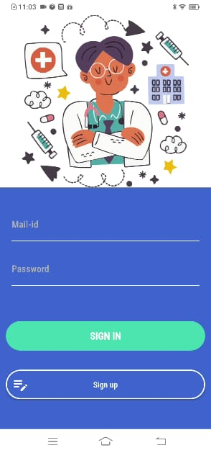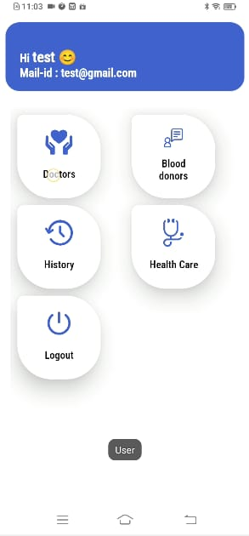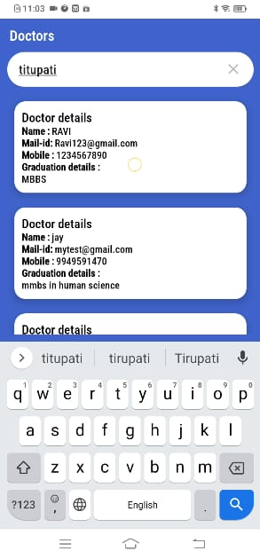

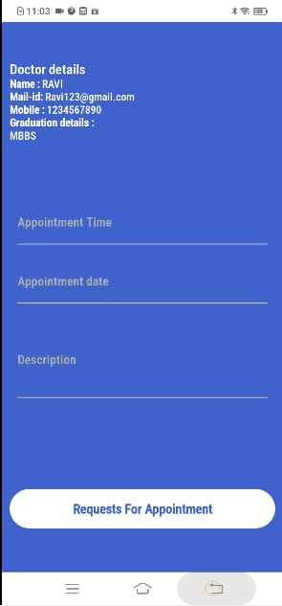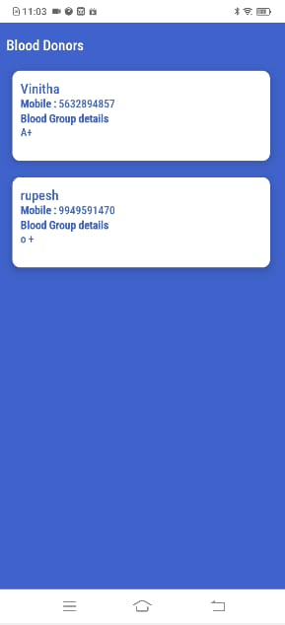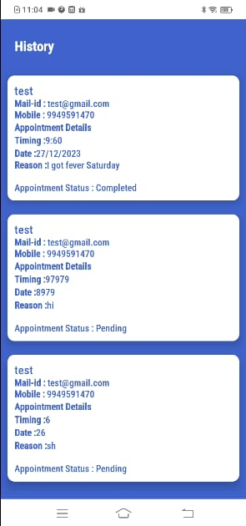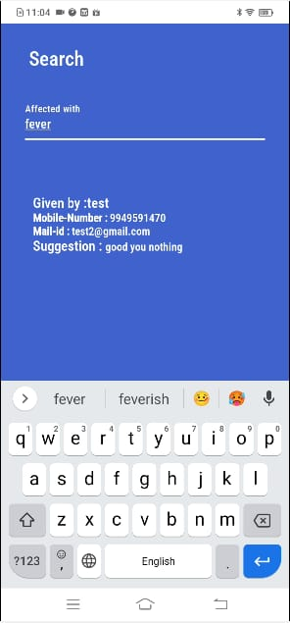

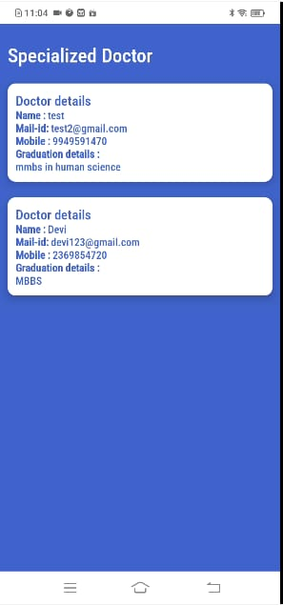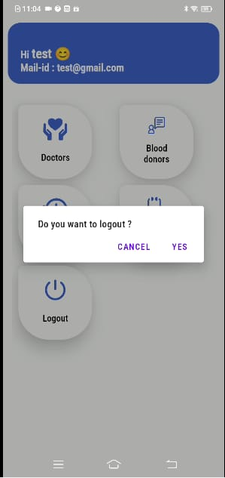

**APPENDIX-C**

**ENCLOSURES**

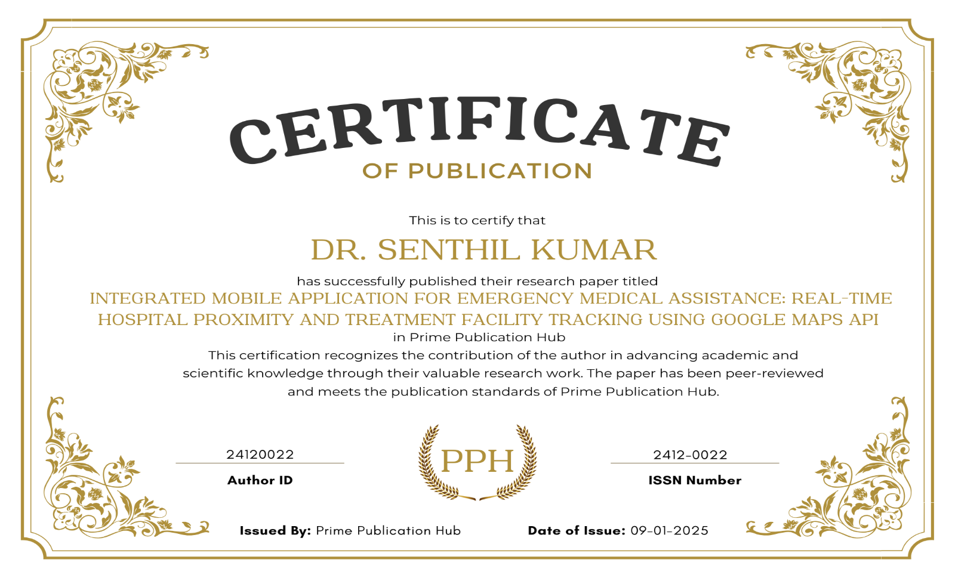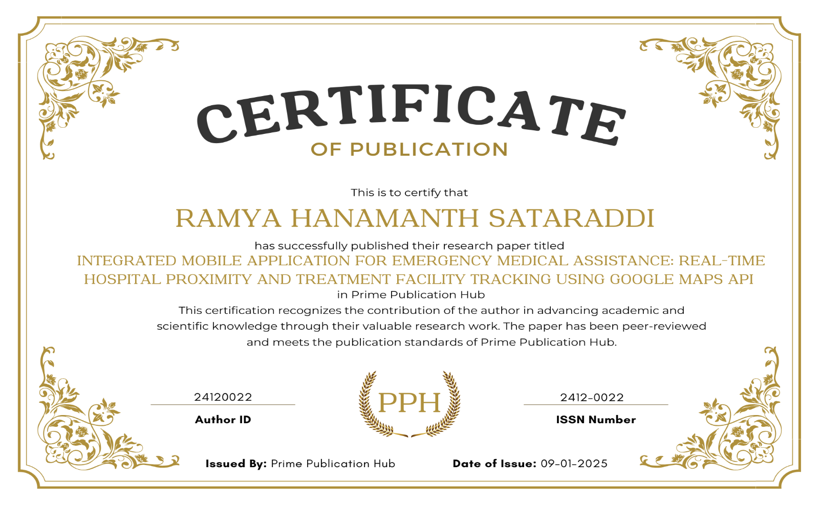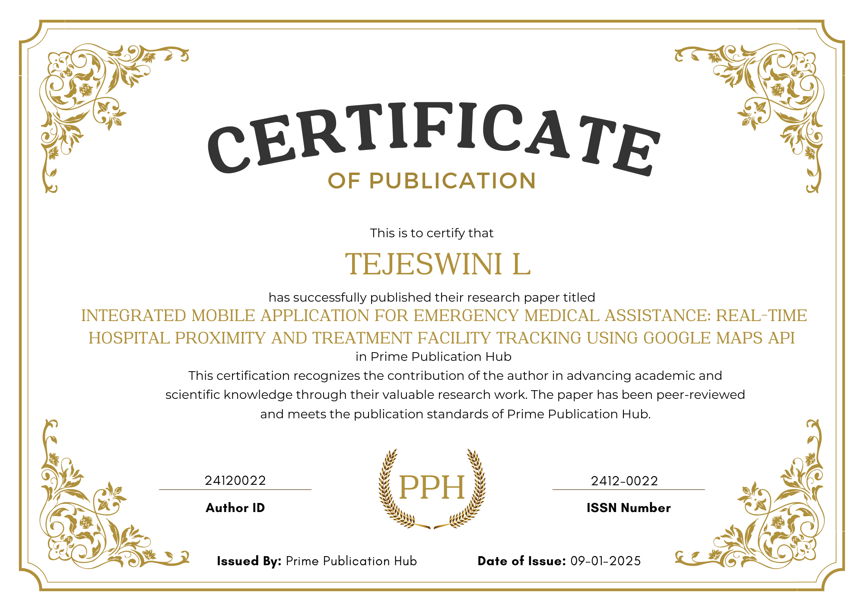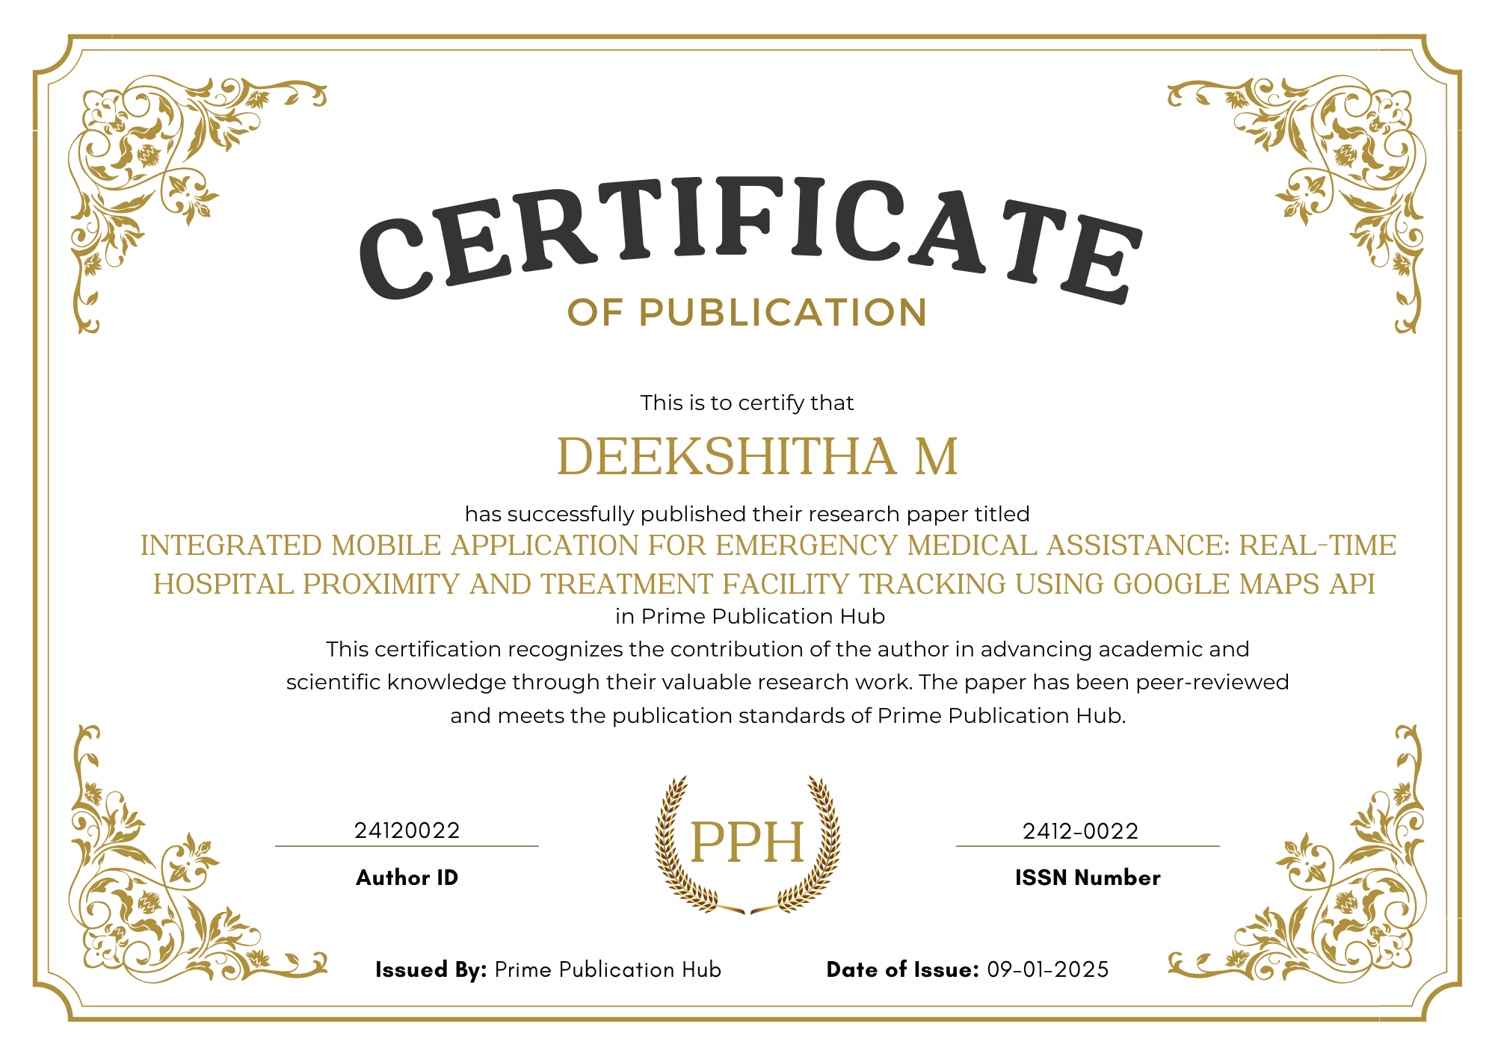

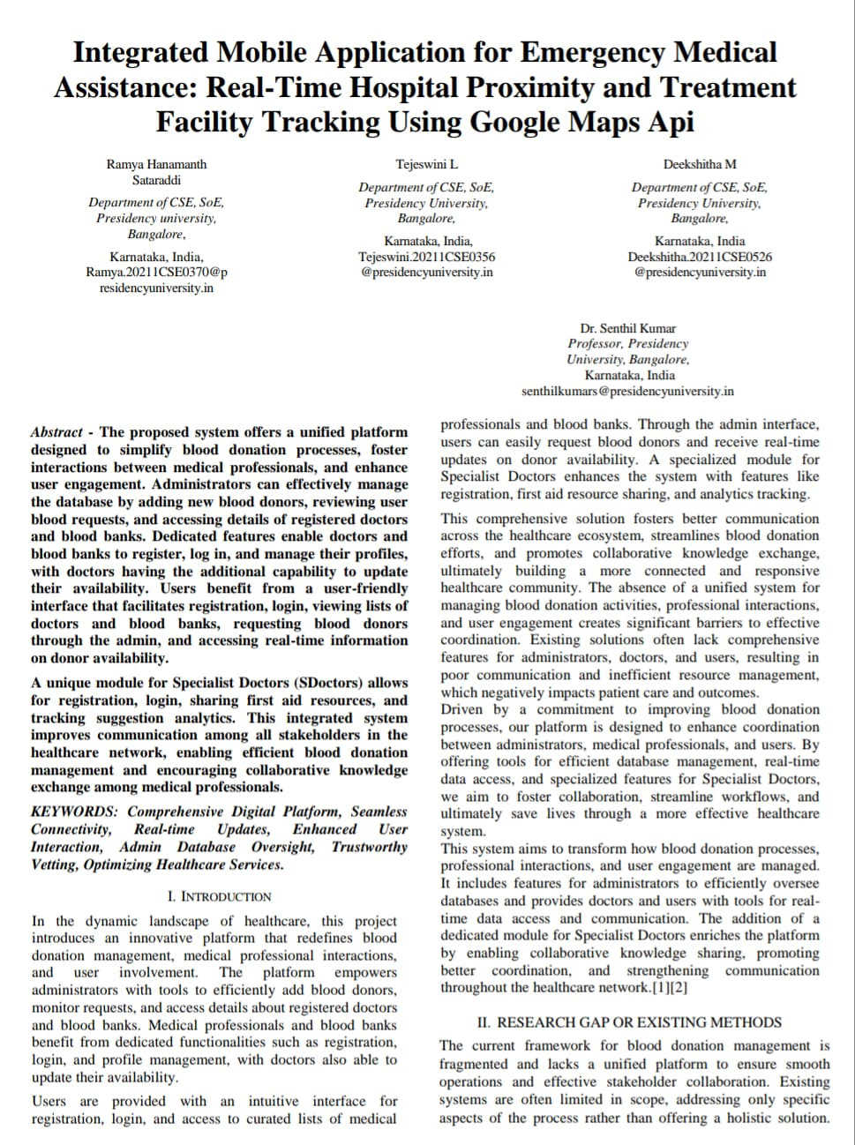

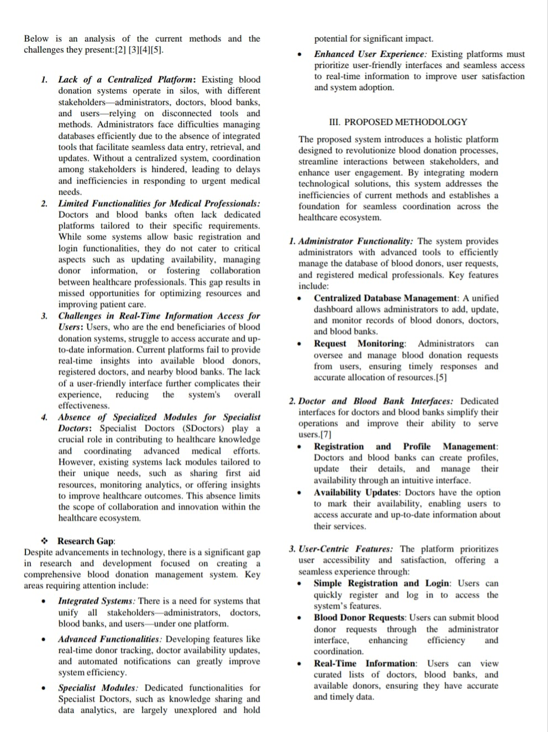

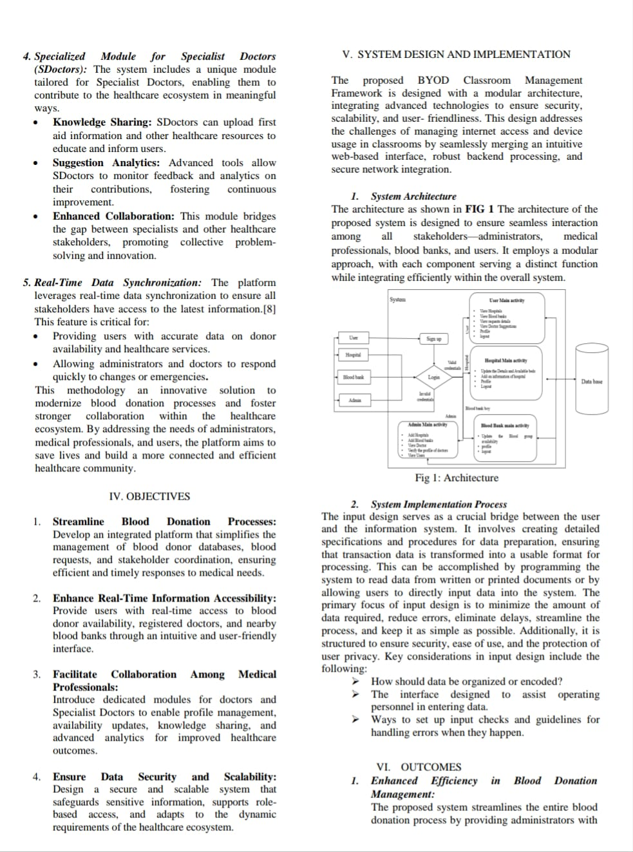

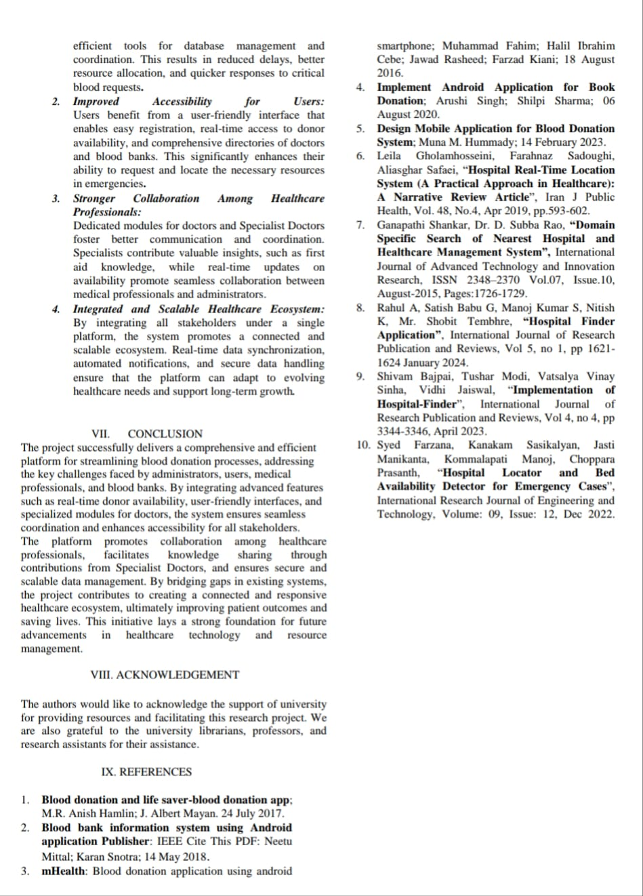

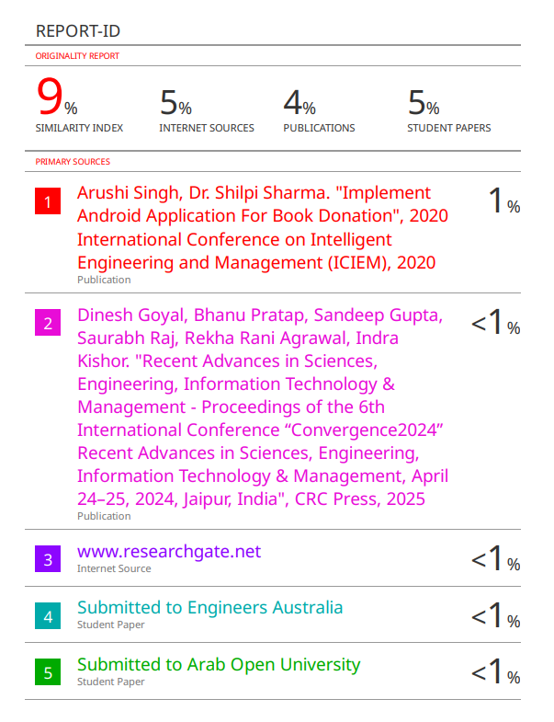

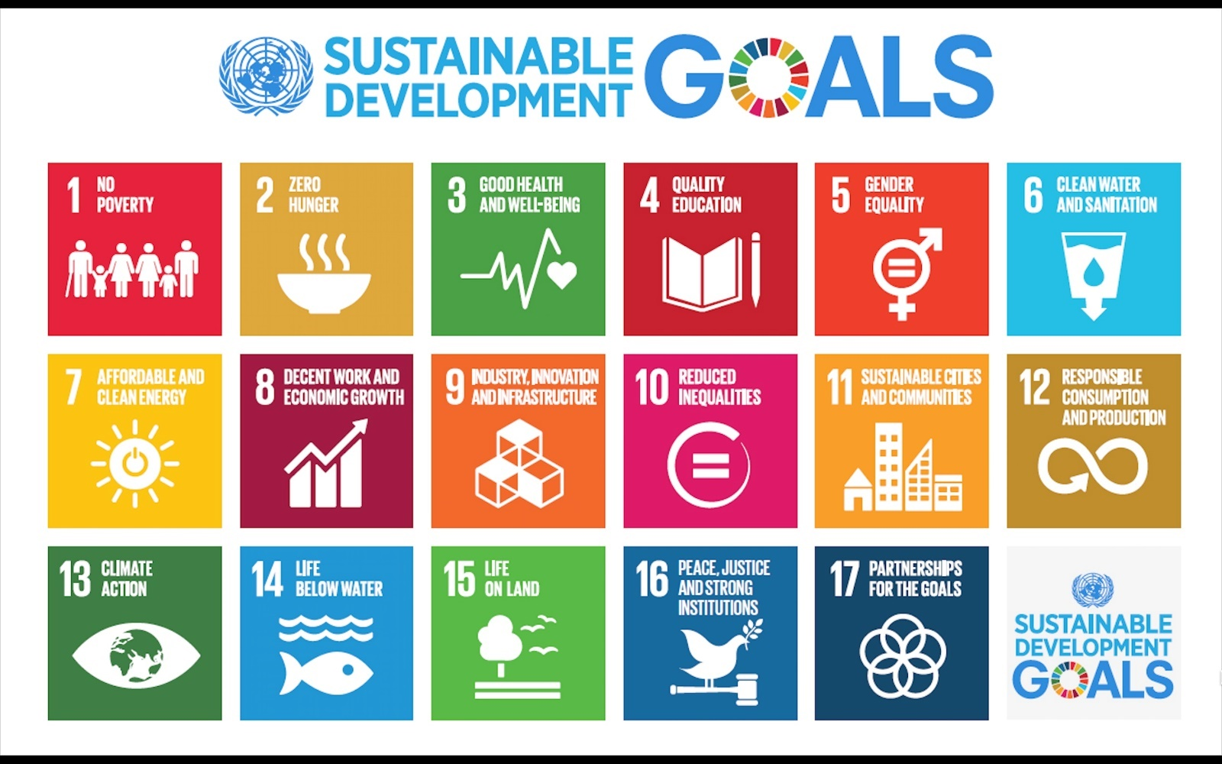

**1. Goal 3: Good Health and Well-being**

**Objective:** Ensure healthy lives and promote well-being for all at all ages.

* Impact of the App:
  + Emergency Healthcare Access: By providing real-time hospital proximity and facility tracking, the app ensures timely access to medical care during emergencies, potentially saving lives.
  + Blood Availability: The integrated blood donor feature bridges the gap between donors and recipients, reducing delays in critical situations.
  + Statistics Support: Aligns with Target 3.8 by improving access to quality healthcare services and Target 3.2 by addressing preventable deaths through efficient medical response.

**2. Goal 11: Sustainable Cities and Communities**

**Objective:** Make cities and human settlements inclusive, safe, resilient, and sustainable.

* Impact of the App:
  + Urban Healthcare Accessibility: Helps residents navigate healthcare options within their locality, reducing the time and effort in finding medical assistance.
  + Community Engagement: The app connects blood donors with recipients, fostering a culture of shared responsibility and mutual aid.
  + Emergency Preparedness: Supports Target 11.6 by reducing the negative impacts of healthcare inaccessibility in urban areas.